

**Movie Theater**

Software Requirements Specification

Version 1.2

**Cantho, May 2025**

**Approval Page**

**Prepared** **by** **:**

Business Analyst

Signature:

Date:



/ /

**Reviewed** **by** **:**

Business Analyst

Signature:

Date:



/ /

**Supported** **by:** Signature:



Date:

/ /

**Approved** **by** **:** Signature:



Date:

/ /

**Revision History**

|  |  |  |  |
| --- | --- | --- | --- |
| **Date** | **Version** | **Author** | **Change** **Description** |
| 02/06/2025 | 1.0 |  | Create new |
| 04/06/2025 | 1.2 |  | Update |
| 05/06/2025 | 1.3 |  | Update guest, member |
| 09/06/2025 | 1.4 |  | Update member |
| 19/06/2025 | 1.5 |  | Update admin |
| 24/06/2025 | 1.7 |  | Update system for admin |
| 11/07/2025 | 1.2 |  | Update about email |
|  |  |  |  |

**TABLE OF CONTENTS**

**1. INTRODUCTION**

1.1 Purpose  
1.2 In Scope

**2. OVERVIEW**

2.1 Actors

* Guest
* Member
* Staff
* Admin

2.2 Use Case Diagram

**3. Functional Description**

**3.1 Functional Requirements**

**3.1.1 User Features**

* Login
* Forgot Password
* Register Account
* Edit Profile
* Change Password
* View Booking History
* View Score History
* View Favourite Movies

**3.1.2 Ticket Booking (Member)**

* Select Movie
* Select Showtime
* Select Seats
* Confirm Booking
* View Ticket Information
* VNPay Payment Integration
* Payment Result Page

**3.1.3 Ticket Selling (Admin/Employee)**

* Select Movie and Showtime
* Select Seats
* Confirm Ticket
* View Ticket Information

**3.1.4 Ticket Booking Management (Admin/Employee)**

* Search Bookings
* View Booking List
* Confirm Booking
* Convert to Ticket

**3.1.5 Employee Management**

* View Employee List
* Add Employee
* Edit Employee
* Delete Employee

**3.1.6 User Management**

* View Users
* Ban/Unban User
* View Ban Message

**3.1.7 Cinema Room Management**

* View Room List
* Add Room
* Edit Room
* Delete Room
* View Room Details

**3.1.8 Movie Management**

* View Movie List
* Add Movie
* Edit Movie
* Delete Movie

**3.1.9 Promotion Management**

* View Promotion List
* Add Promotion
* Edit Promotion
* Delete Promotion

**3.2 Non-Functional Requirements**

* Logical Structure of the Data
* Security
* Performance

1. **INTRODUCTION**

## Purpose

The Movie Theater Management System is designed to streamline the daily operations of a cinema, focusing on efficient ticket booking for users and ticket selling for employees. The system aims to enhance employee productivity, reduce ticketing time per customer, simplify the booking experience, increase revenue, reduce reliance on manual labor, and help the theater remain competitive in the entertainment industry.

The system incorporates role-based access control, ensuring that users interact with features appropriate to their role:

· Customers (not registered members) can browse the movie list, view ongoing promotions, check ticket prices and showtimes, create an account, and log in.

· Members (registered users) have all the capabilities of regular customers, with added functions such as booking tickets, managing their personal information, and tracking bookings.

· Employees can search for and manage member information, oversee movie and showtime schedules, handle ticket sales, and administer promotions.

· Managers/Admins are granted full access, including employee management, statistical reporting, and the management of users, promotions, and cinema room configurations.

## In scope

This project is developed as part of a learning-based mock system, aiming to simulate the essential features of a real-world movie theater management platform. The system supports basic and extended functionalities such as user registration, movie browsing, ticket booking, ticket selling, and administrative operations like employee and movie management.

It serves as a foundational project to:

· Apply theoretical knowledge into practice.

· Understand system development lifecycle.

· Prepare for more complex, real-life software development projects.

The system is designed to be web-based, allowing interaction between multiple user roles including customers, employees, and administrators through distinct interfaces.

# OVERVIEW

## Actors

The following table describes actors of the movie theatre management system.

|  |  |
| --- | --- |
| **Actor** | **Description** |
| Guest | A visitor who has not registered or logged in. Can view the list of movies, ticket prices, promotions, and showtimes. Can also create an account to become a member. |
| Member | A registered user. Has access to all guest features, and can additionally book tickets, view and manage personal bookings, earn and use points, and update account details. |
| Staff | A theater employee responsible for handling customer ticket sales, booking support, and member-related queries. Can also manage movie schedules, promotions, and basic customer info. |
| Admin | A system administrator or theater manager. Has full control over the system, including management of users (staff and members), movies, showtimes, cinema rooms, promotions, and statistical reports. |

## USE CASE DIAGRAM

The diagram below provides an overview of the function as well as actors of the users

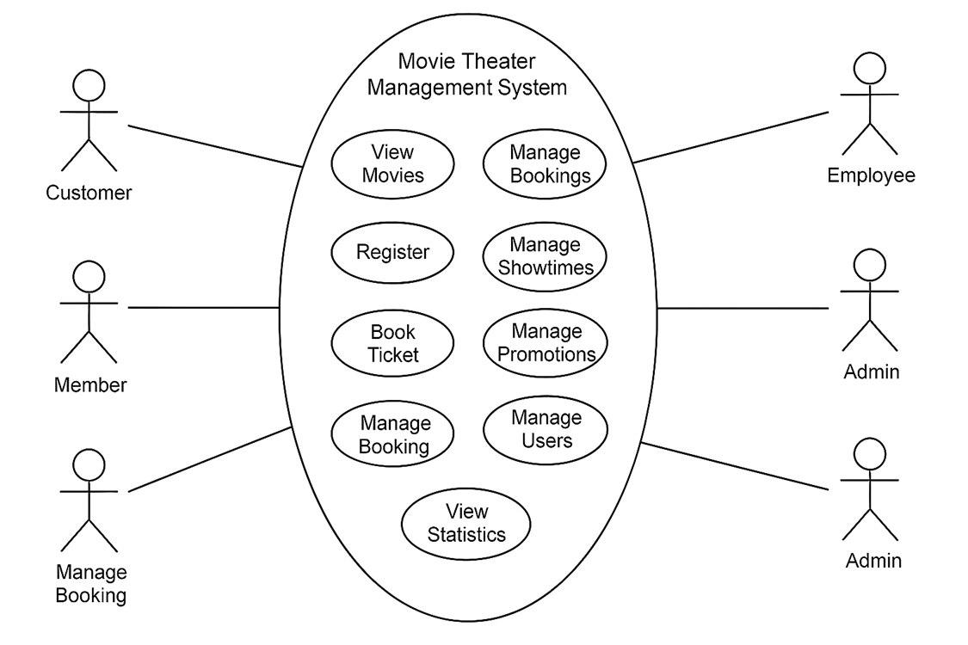

# Functional Description

# 3.1 Functional Requirements

### Log in

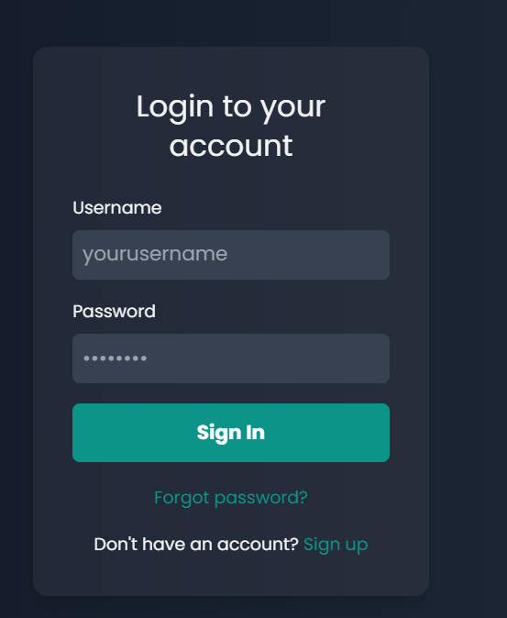

**Users must be authenticated with the provided account and password to access the system.**

The system requires users to authenticate using a valid username and password through the login page. Upon form submission, the system verifies the credentials against the user database.

- If the username does not exist or the password is incorrect, the system displays an error: "Login failed".

- If the account exists but is banned, the user is redirected to a ban notification page with details including the ban reason and date.

- If the login is successful and the account is active, the user data is stored, roles are checked, and the user is navigated to the main screen of the application.

### Forgot Password

|  |  |  |  |  |
| --- | --- | --- | --- | --- |
| **Screen** | Forgot Password | | | |
| **Description** | Reset account password by verifying user email and confirming human identity using CAPTCHA. | | | |
| **Screen**  **Access** | The user clicks **"Forgot Password"** to access this screen. | | | |
| **Screen Content** | | | | |
| **Item** | **Type** | **Data** | **Description** | |
| Email | Textbox-  String | N/A | User enters their registered email address. | |
| CAPTCHA | TextBox -  String | N/A | Google reCAPTCHA v2 is used to verify the user is not a bot. | |
| Send Information | Textbox -  String | N/A | Triggers password recovery process via API. | |
| Back to Login | Textbox -  String | N/A | Redirects user back to the login screen. | |
| **Screen action** | | | | |
| **Action name** | **Description** | | **Success** | **Failure** |
| Fill Email | User enters a valid email address | | Email is stored | Error toast: "Please enter your email" |
| Solve CAPTCHA | User completes the CAPTCHA challenge | | Token stored in captchaToken | Error toast: "Please verify Captcha!” |
| Send Information | Click button to trigger /api/forgot-password API | | Success toast + redirect to login page | Error toast with API message |
| Back to Login | Navigates back to login screen (/login) | | User redirected | N/A |

### Register account

|  |  |
| --- | --- |
| Use Case Name | Register account |
| Use Case ID |  |
| High Level Requirement Ref | High |
| Actor | User |
| Description | This is use case which allows the user to register accounts |
| Trigger | NA |
| Pre-condition | The user registers account information |
| Post-processing |  |

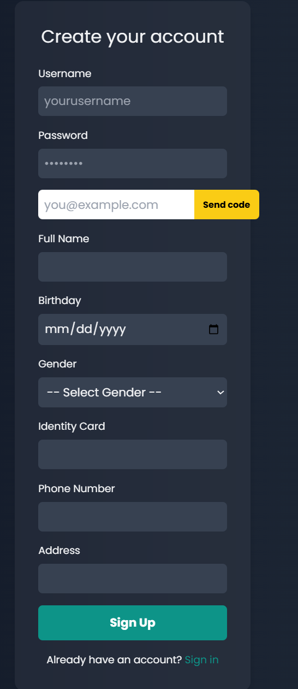

|  |  |  |  |  |
| --- | --- | --- | --- | --- |
| **Screen** | Register account | | | |
| **Description** | Register a new user by filling out personal details and verifying email using a one-time code. | | | |
| **Screen**  **Access** | The user clicks **"Register account"** to access this screen. | | | |
| **Screen Content** | | | | |
| **Item** | **Type** | **Data** | **Description** | |
| Username | Textbox-  String | N/A | Account username | |
| Password | TextBox -  String | N/A | Account password | |
| Email | Textbox -  String | N/A | User's email, used for account verification | |
| Send code | Button | N/A | Sends verification code to the email | |
| Verification code | Textbox -  String | N/A | Code entered by user after clicking **Send code** (appears only after send | |
| Full Name | Radiobutton  - String | N/A | User's full name | |
| Birthday | Date Picker | N/A | User's birthdate | |
| Gender | Dropdown |  | Select from: Male / Female / Other | |
| Identity card | Texbox -  number | N/A | Identity number (CMND/CCCD) | |
| Phone  number | Textbox -  Number | N/A | User's phone number | |
| Address | Textbox -  String | N/A | Residential address | |
| Sign up | Button | N/A | Submits registration information | |
| Already have account? | Link/Button |  | Redirects to login screen | |
| **Screen action** | | | | |
| **Action name** | **Description** | | **Success** | **Failure** |
| Fill Form | User enters all required details | | Inputs updated in real-time | Error message if field validation fails |
| Send Code | Sends code to email using /api/send-verify-code | | Shows toast: “Verification code has been sent to your email!” | Toast error: “Failed to send verification code!” |
| Register | Submits data to /api/register | | Toast: "Registration successful! Please log in" and redirect to /personal | Toast error with backend message or fallback message |

**3.1.3.1 Edit user profile**

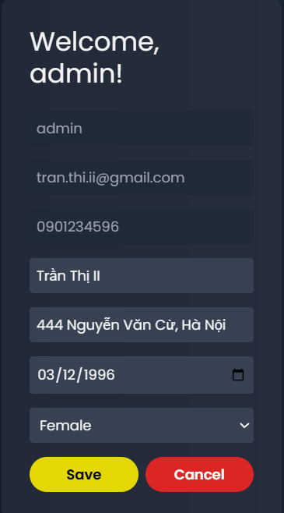

|  |  |
| --- | --- |
| **Screen** | Edit Profile |
| **Description** | Allows a logged-in user to edit personal information such as name, address, birthday, and gender |
| **Screen**  **Access** | Logged-in users only |

|  |  |  |  |  |
| --- | --- | --- | --- | --- |
| **Screen Content** | | | | |
| **Item** | **Type** | **Data** | **Description** | |
| Username | Text Field (read-only) | N/A | Cannot be edited; displayed in disabled style | |
| Email | Text Field (read-only) | N/A | Cannot be edited; displayed in disabled style | |
| Phone Number | Text Field (read-only) | N/A | Cannot be edited; displayed in disabled style | |
| Name | Textbox -  String | N/A | Editable full name of user | |
| Address | Textbox -  String | N/A | Editable address of user | |
| Birthday | Date Picker | N/A | Editable birthdate | |
| Gender | Dropdown | Male / Female / Other | Selectable gender | |
| **Screen action** | | | | |
| **Action name** | **Description** | | **Success** | **Failure** |
| |  | | --- | | Edit Field |  |  | | --- | |  | | User enters or changes values in editable fields | | Fields are updated in local form state | N/A |
| Save | Sends a POST request to update user profile (/api/profile) | | User data is saved, parent state is updated, screen exits edit mode | Error alert shown |
| Cancel | Exits edit mode without saving | | Returns to previous view or disables editing | N/A |

**3.1.3.2. Change user password**

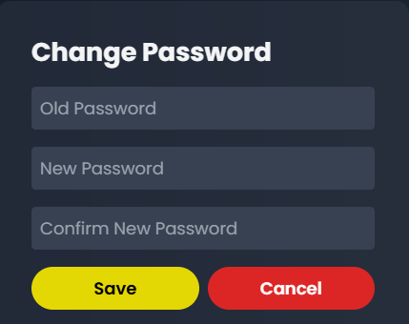

|  |  |
| --- | --- |
| **Screen** | Change Password |
| **Description** | Allows a logged-in user to change their password |
| **Screen**  **Access** | Authenticated users only |

|  |  |  |  |  |
| --- | --- | --- | --- | --- |
| **Item** | **Type** | **Data** | **Description** | |
| Title | Text |  | Heading of the page | |
| Old Password | Password Input |  | |  | | --- | | User’s current password |  |  | | --- | |  | | |
| New Password | Password Input |  | New password user wants to set | |
| Confirm New Password | Password Input |  | Used to confirm the new password | |
| Error Message | Text (if error) |  | Displays validation or server error | |
| Success Message | Text (if success) |  | |  | | --- | | Displays success feedback |  |  | | --- | |  | | |
| Save Button | Button |  | Triggers password change request | |
| Cancel Button | Button |  | Navigates back to personal info screen |  |
| **Screen action** | | | | |
| **Action name** | **Description** | | **Success** | **Failure** |
| Input Change   |  | | --- | |  | | User enters values in any of the password fields | | Form state updates accordingly | N/A |
| Password Mismatch | When newPassword !== confirmPassword | | N/A | Error message: "New passwords do not match" |
| Submit Form | Validates input and sends password change request to server | | Displays success message and resets form | Displays server error (e.g., incorrect old password) |
| Cancel | Click "Cancel" button | | Navigates back to /personal | N/A |

**3.1.3.3.** **Edit member accounts**

|  |  |  |  |  |
| --- | --- | --- | --- | --- |
| **Screen** | Edit employee account | | | |
| **Description** | Display and allow editing of a member's account information | | | |
| **Screen**  **Access** | The user clicks the "Edit" icon (✏️) from the Employee Dashboard card. | | | |
| **Screen Content** | | | | |
| **Action name** | **Description** | **Success** | **Failure** | |
| Username | Textbox -  string | N/A | Required, editable only when adding employee | |
| Password | Textbox –  string | N/A | Required when adding, hidden on edit | |
| Email | Textbox -  string | N/A | Required | |
| Full Name | Textbox -  date | N/A | Required | |
| Birthday | Radiobutton  - string | N/A | Required | |
| Gender | Dropdown  string | N/A | Required (Male, Female, Other) | |
| Identity card | Textbox -  string | N/A | Required | |
| Phone  number | Textbox -  number | N/A | Required | |
| Address | Textbox -  string | N/A | Required | |
| Save | Button | N/A | Submit changes to backend | |
| Cancel | Button | N/A | Close modal without saving | |
|  |  |  |  | |
|  |  | N/A |  | |
|  |  | N/A |  | |
| **Screen action** | | | | |
| **Action name** | **Description** | | **Success** | **Failure** |

|  |  |  |  |
| --- | --- | --- | --- |
| Save | Submit updated employee data to the backend | Modal closes, employee updated | Error toast, stays on modal |
| Cancel | Close modal without saving any changes | Modal closes | N/A |
|  |  |  |  |
|  |  |  |  |
|  |  |  |  |

### Account management of the user

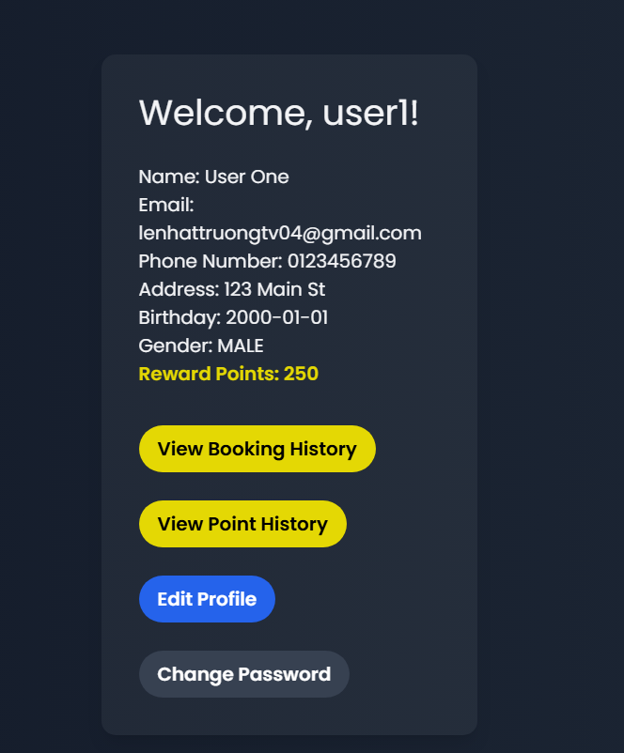

|  |  |
| --- | --- |
| Use Case  Name | Account management |
| Use Case ID |  |
|  |  |
| Actor | Member |
| Description | This is a use case which allows the users to update information, change  password, manage ticket booking, view detail of score adding and use the score. |
| Trigger | NA |
|  |  |
| Pre-condition | The user with registered account |
| Post-  processing |  |

* + - 1. **The user – Booked ticket management**

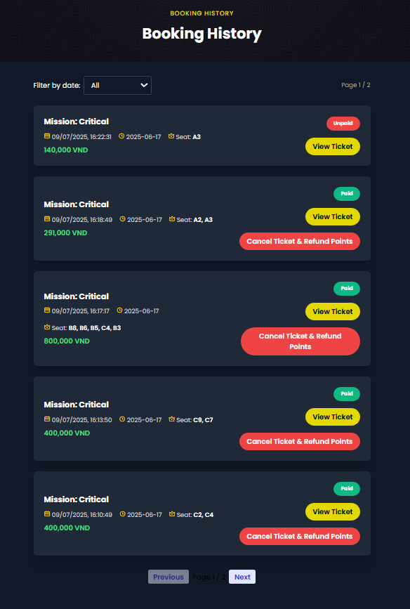

|  |  |  |  |
| --- | --- | --- | --- |
| **Screen** | Booking History | | |
| **Description** | Display all booked tickets | | |
| **Screen**  **Access** | Member clicks Account management ->View booking history | | |
| **Screen Content** | | | |
| **Item** | **Type** | **Data** | **Description** |
| Movie name | label-  string | N/A |  |
| Filter by date | Dropdown | Date string (YYYY-MM-DD) | Allows users to filter bookings by booking date |
| Booking date | Label- string | DateTime | Date and time when the booking was made |

|  |  |  |  |  |
| --- | --- | --- | --- | --- |
| Show Date | Label -  String | Date (e.g., 2025-06-17) | Date of the scheduled movie | |
| Seat | Label -  String | List of seat codes | Seat(s) booked for the selected movie | |
| Price | Label -  Number | VND | Total price for the booking | |
| Status | Label -  String | "Paid" / "Unpaid" | Indicates payment status of the booking | |
| View Ticket | Button | N/A | Opens a modal with full ticket details | |
| Cancel & Refund | Button (conditional) | N/A | Only shown if booking is paid. Cancels ticket and refunds points | |
| Pagination | Navigation Buttons | Page numbers | Navigate between pages of booking history | |
| Ticket Modal | Popup Dialog | Object of ticket data | Displays all ticket info: version, show time, room, seat, price, etc. | |
| **Screen Action** | | | | |
| **Action name** | **Description** | | **Success** | **Failure** |
| Filter Bookings by Date | Select a date from the dropdown to filter the booking records | | Displays filtered bookings based on selected date | No records shown or filtered incorrectly |
| View Ticket Details | Click the "View Ticket" button to open a modal showing detailed info | | Modal opens with correct ticket data | Modal shows error or empty content |
| Cancel Ticket & Refund | Click the "Cancel Ticket & Refund Points" to cancel a paid booking | | Ticket is cancelled and points are refunded; list reloads | Alert error or no change in history list |
| Navigate Pages | Use Previous / Next buttons to navigate between booking history pages | | Booking list updates according to selected page | Buttons do not respond or page doesn't change |

* + - 1. **The user – View history of score adding/using**

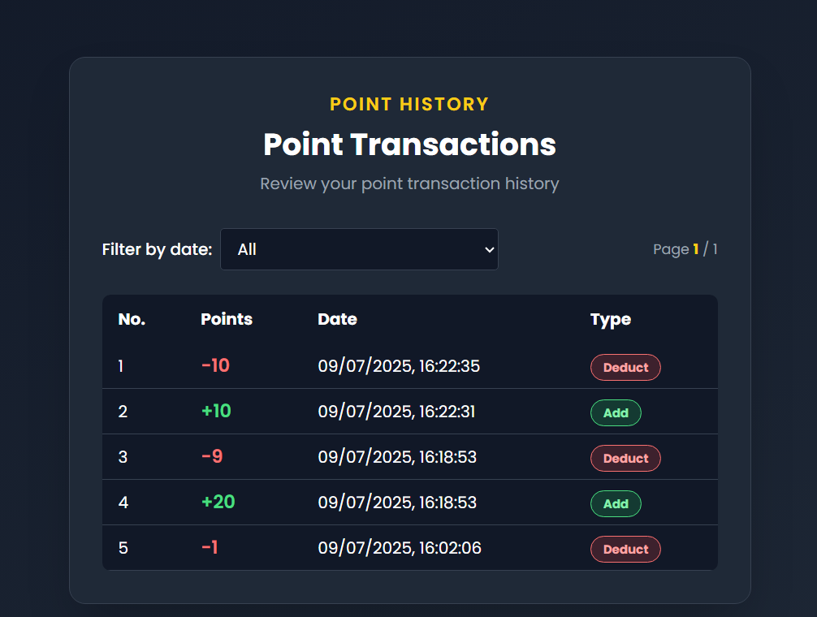

|  |  |  |  |  |
| --- | --- | --- | --- | --- |
| **Screen** | View history of score adding/using | | | |
| **Description** | Display all history of score adding/using of the current member | | | |
| **Screen**  **Access** | The member clicks account management -> History | | | |
| **Screen Content** | | | | |
| **Item** | **Type** | **Data** | **Description** | |
| Filter by date | Dropdown - string | List of available dates + "All" option | Allows user to filter point history by specific date or view all transactions | |
| No. | Label - Integer | Auto increment index | Sequential number of the transaction on current page | |
| Points | Label - String | +Number / -Number | Displays added or deducted points; positive numbers in green, negative in red | |
| Date | Label - datetime | rewardDate (formatted) | Date and time when the transaction occurred | |
| Type | Label - string | "Add" or "Deduct" | Indicates whether the transaction is adding points or deducting points | |
| Pagination | Controls (Buttons & Text) | "Previous", "Next", current page / total pages | Allows user to navigate through pages of transactions | |
| **Screen Action** | | | | |
| **Action name** | **Description** | | **Success** | **Failure** |
| Filter by Date | Select a date from the dropdown to filter | | Displays point transactions that match the selected date | Shows "No point history." if no data is found |
| Pagination | Navigate to previous or next | | Displays transactions on the selected page | Buttons are disabled if already at first/last page |

* + - 1. **The user – View history of score adding/using**

|  |  |  |  |  |
| --- | --- | --- | --- | --- |
| **Screen** | Favourites | | | |
| **Description** | This screen displays the list of favorite movies saved by the user (watchList). Each movie is shown using the MovieCard component. If there are no favorites, a message from NoData component is shown. | | | |
| **Screen**  **Access** | Accessible from the site menu or user profile when the user wants to view their favorite or bookmarked movies. | | | |
| **Screen Content** | | | | |
| **Item** | **Type** | **Data** | **Description** | |
| Page title | Label | "My Favourites" | Title shown at the top of the screen | |
| Sub-heading | Label | "ONLINE STREAMING" | Secondary section heading | |
| Section title | Label | "my watch List" | Main section title showing movie list | |
| Movie cards | Dynamic | Movie data from watchList | Displayed using MovieCard component | |
| No data message | Component | N/ | Shown via NoData if watchList is empty | |
| Subscription block | Component | Subscribe component | Displayed at the bottom of the page | |
| **Screen Action** | | | | |
| **Action name** | **Description** | | **Success** | **Failure** |
| Load watchList | Maps and displays favorite movies in the grid | | Movies rendered via MovieCard | NoData message shown |
| Remove from list | (If implemented in MovieCard) allows users to remove a movie from favorites | | Movie removed and list updates | No feedback or error message |

### Booking ticket of the user

|  |  |
| --- | --- |
| Use Case  Name | Booking ticket |
| Use Case ID |  |
|  |  |
| Actor | Member |
| Description | This is the use case which allows users to book ticket |
| Trigger | NA |
| Pre-condition | The user must login account |
| Post-  processing |  |

* + - 1. **Book ticket – Select movie**

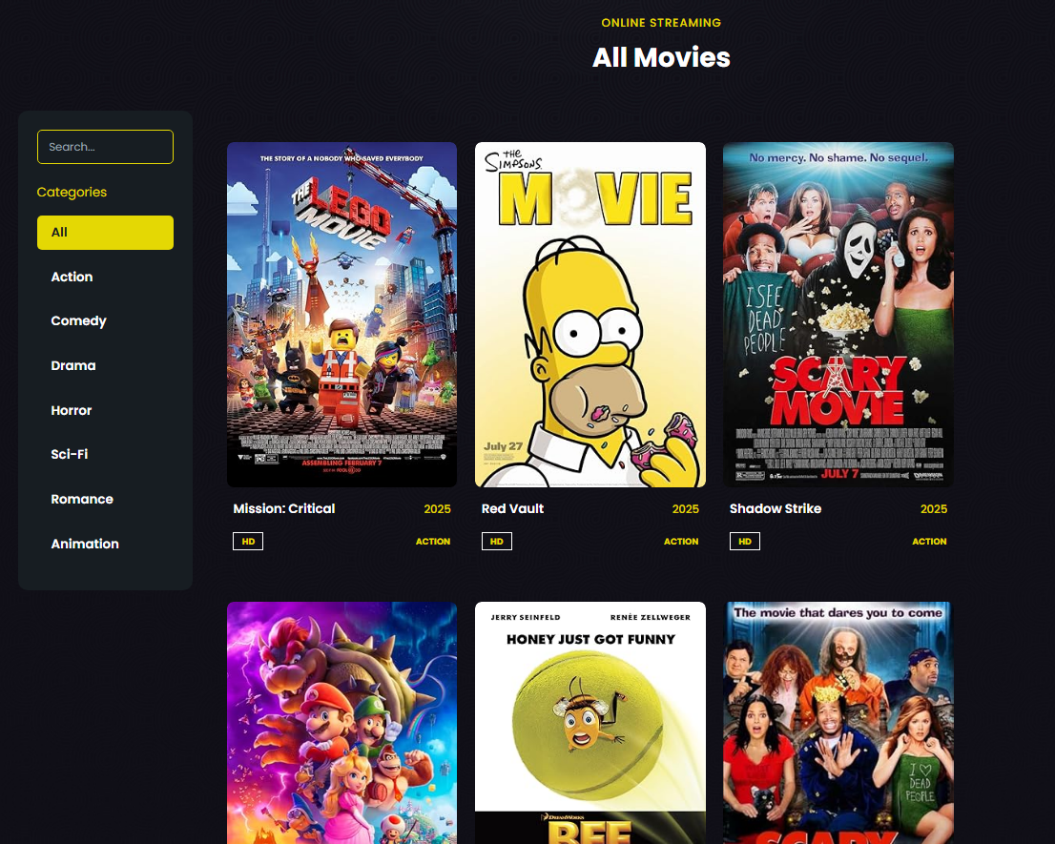

|  |  |  |  |  |
| --- | --- | --- | --- | --- |
| **Screen** | Book ticket – Select movie | | | |
| **Description** | Display the current movies | | | |
| **Screen**  **Access** | The user accesses to Movies | | | |
| **Screen Content** | | | | |
| **Item** | **Type** | **Data** | **Description** | |
| Select movie | Input - String | Movie name (partial) | Allows the user to search movies by name | |
| Categories | Button list | Genre names | Filters the movie list based on selected genre | |
| Show Dates | Button list | Date string | Filters the movie list based on available showtimes | |
| Clear Date Filter | Button | N/A | Resets the selected show date and reloads the full list | |
| Movie Card | Card Component | Movie details | Displays image, title, year, genre badge for movie | |
| Pagination | Component | Page numbers | Navigate between pages of movie results | |
| **Screen action** | | | | |
| **Action name** | **Description** | | **Success** | **Failure** |
| Select movie | Enter movie name in search bar | | Filters and displays matching movies | Displays “No data found” message |
| Select category | Click a genre button to filter movies | | Displays movies of selected genre | Displays empty state if no movies match |
| Select show date | Click a show date button to filter movies by date | | Displays movies available on that date | No movies shown if none are scheduled |
| Clear date filter | Click “Clear Date Filter” button | | Reloads full list with date filter removed | N/A |
| Click on Movie card | (If wired) Navigate to movie details or booking | | Movie detail page loads | Stays on the same page if not configured |
| Navigate pagination | Click previous/next/page number | | Loads corresponding movie list page | Page does not change if clicked page invalid |

* + - 1. **Booking ticket – Selecting showtime**

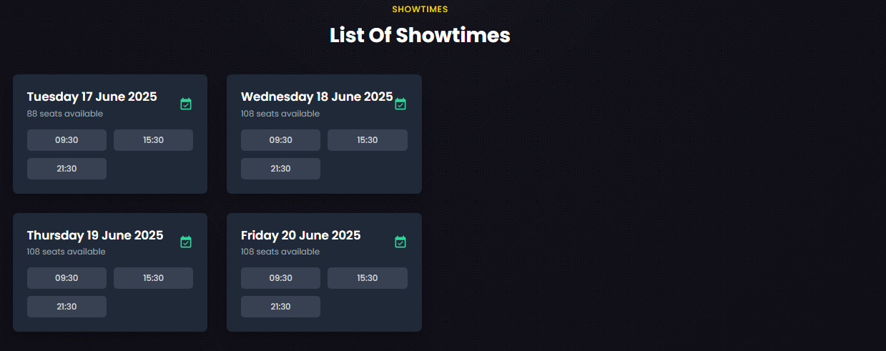

|  |  |  |  |  |
| --- | --- | --- | --- | --- |
| **Screen** | Book ticket – List of Showtimes - Select showtime | | | |
| **Description** | Display available showtimes grouped by date for the selected movie | | | |
| **Screen**  **Access** | Member clicks Movie -> Book Movie | | | |
| **Screen Content** | | | | |
| **Item** | **Type** | **Data** | **Description** | |
| Date (show_date) | Label - String | e.g. Tuesday, 17 June | The date of available showtimes | |
| Seats available | Label - Number | e.g. 88, 108 | Number of available seats for the day/schedule | |
| Showtime | Button | e.g. 09:30, 15:30 | Specific time for the show - clickable to navigate to seat | |
| Calendar icon | Icon | N/A | Visual indicator next to date | |
| **Screen action** | | | | |
| **Action name** | **Description** | | **Success** | **Failure** |
| Select Showtime | Click a showtime button to view available seats and book | | Navigates to /seat-map/{movieId}/{showDateId}/{scheduleId} | Showtimes not loading or unavailable |
| Hover on Showtime | Hover over a showtime to view specific seat availability for that time | | Updates seat availability text | No hover effect if JavaScript is broken |

* + - 1. **Booking ticket – Selecting seat**

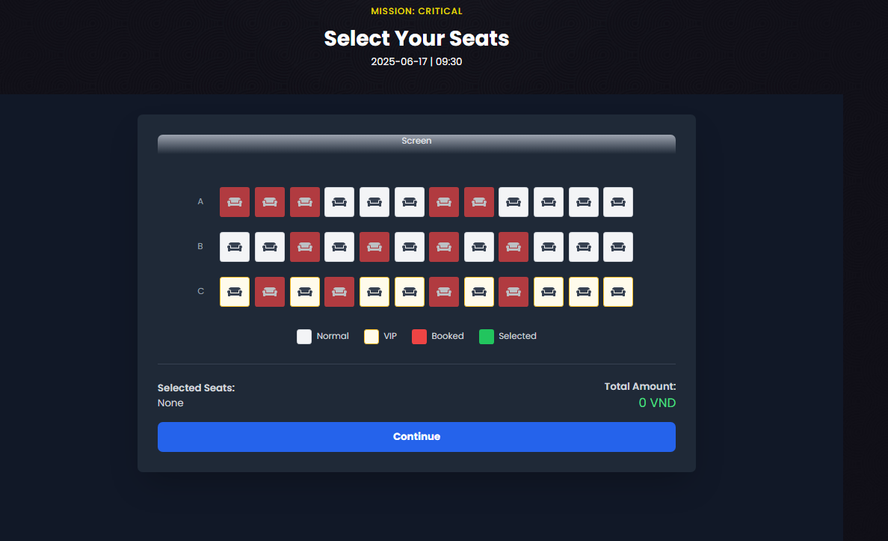

|  |  |  |  |  |
| --- | --- | --- | --- | --- |
| **Screen** | Booking ticket – Selecting seats | | | |
| **Description** | Display seat map for user to select seats for a chosen showtime. | | | |
| **Screen**  **Access** | The member selects a movie → chooses a showtime → is directed to the seat selection screen. | | | |
| **Screen Content** | | | | |
| **Item** | **Type** | **Data** | **Description** | |
| Movie name | Label - string | N/A | The title of the movie currently being booked | |
| Showtime (date and time) | Label - string | N/A | The scheduled date and time for the show | |
| Seat map | Visual grid | N/A | A grid showing seats grouped by rows; each seat has a code and type | |
| Seat types (Legend) | Label - icon + string | Normal, VIP, Booked, Selected | Each color indicates seat status (gray = normal, yellow = VIP, red = booked, green = selected) | |
| Tooltip on hover | Tooltip - string | N/A | Shows seat code, seat type, and status | |
| Selected seats | Label - string | N/A | Displays list of selected seats | |
| Total price | Label - number | N/A | Shows the price calculated based on selected seats | |
| Continue button | Button | N/A | When clicked, confirms selection and moves to the next step | |
| **Screen Action** | | | | |
| **Action name** | **Description** | | **Success** | **Failure** |
| Select seat | User clicks on an available seat to select/deselect it | | Seat is marked as selected (turns green), price is updated | Seat is already booked (no action) |
| Select seat | User clicks "Continue" to proceed | | Booking information is saved and user moves to confirmation page | No seats selected → cannot proceed |

* + - 1. **Booking ticket – Confirm booking ticket**

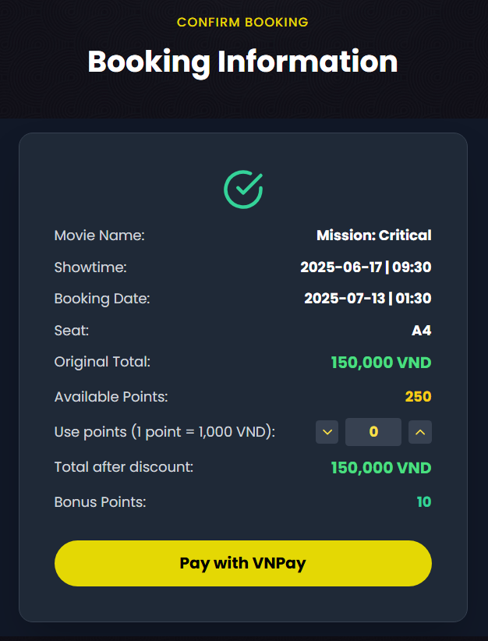

|  |  |  |  |
| --- | --- | --- | --- |
| **Screen** | Booking ticket – Confirm booking ticket | | |
| **Description** | Display summary of selected movie, showtime, seat(s), and payment details. Allows user to apply points and proceed to VNPay payment. | | |
| **Screen**  **Access** | The member selects seat(s) → clicks “Continue” → is directed to the Confirm Booking screen. | | |
| **Screen Content** | | | |
| **Item** | **Type** | **Data** | **Description** |
| Movie name | Label - string | N/A | The title of the movie selected for booking |
| Showtime (date and time) | Label - string | N/A | The scheduled date and time for the show |
| Booking Date | Label - date | N/A | The date and time when the booking is created |
| Selected seats | Label - string | N/A | Shows the list of selected seat codes (e.g., A1, A2) |
| Original total | Label - number | N/A | Displays the total amount before applying any discount |
| Available points | Label - number | N/A | Shows the number of reward points the user currently has |
| Use points input | Input - number (spinner or text field) | N/A | Allows user to enter the number of points to apply (1 point = 1,000 VND) |
| Total after discount | Label - number | N/A | Shows the total amount after points have been applied |
| Earned points | Label - number | N/A | Displays the number of new points the user will earn after this booking |
| Pay with VNPay button | Button | N/A | Initiates payment process using VNPay |

|  |  |  |  |
| --- | --- | --- | --- |
| **Screen Action** | | | |
| **Action name** | **Description** | **Success** | **Failure** |
| Apply points | User inputs number of points to use | Total price is reduced accordingly | User enters more points than available → show error message |
| Click "Pay with VNPay" | User confirms and proceeds to payment | Booking is saved and user is redirected to VNPay gateway | Missing seat selection or server error → show error message |

* + - 1. **VNPay (https://sandbox.vnpayment.vn/)**

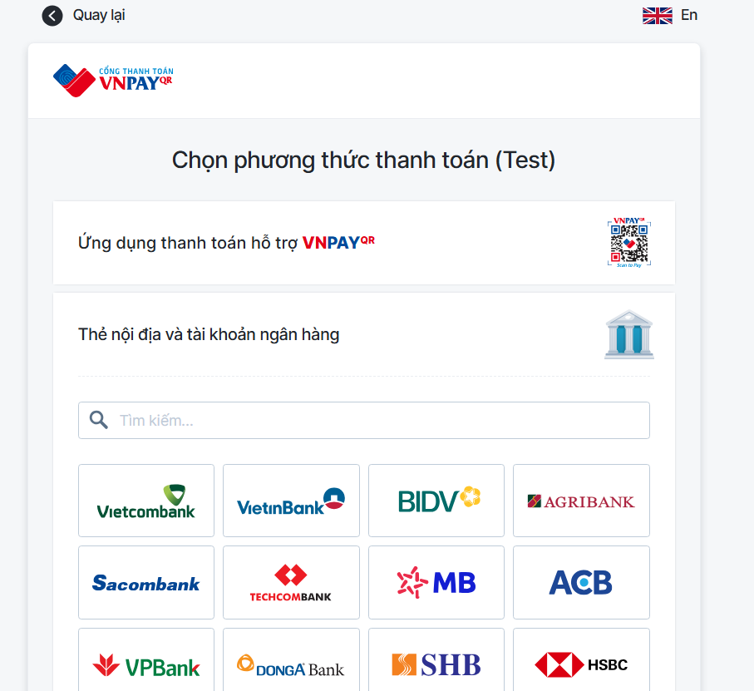

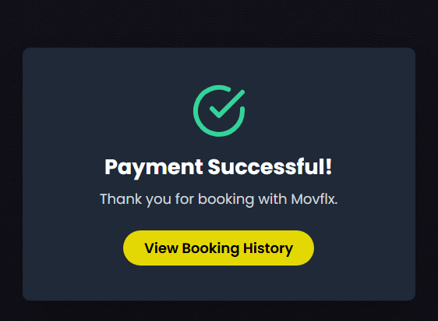

|  |  |  |  |  |
| --- | --- | --- | --- | --- |
| **Screen** | Payment Result (VnpayReturn) | | | |
| **Description** | Displays the result of the payment process after returning from VNPAY gateway. | | | |
| **Screen**  **Access** | After completing payment through VNPAY, the user is redirected to this page. | | | |
| **Screen Content** | | | | |
| **Item** | **Type** | **Data** | **Description** | |
| Status icon | Icon (image) | N/A | Shows green checkmark for success or red cross for failure | |
| **Payment result title** | Label - string | N/A | Displays "Payment Successful!" or "Payment Failed!" depending on status | |
| Payment result description | Label - string | N/A | Gives brief info — "Thank you for booking with Movflx" or "Please try again or contact support." | |
| **Action button** | Button | N/A | Shows either "View Booking History" (on success) or "Back to Home" (on failure) | |
| **Loading message** | Label - string | N/A | If payment is still being processed, shows "Processing payment result..." | |
| **Screen Action** | | | | |
| **Action name** | **Description** | | **Success** | **Failure** |
| Process VNPAY response | On page load, reads query parameters from URL (vnp_ResponseCode, vnp_TransactionStatus) | | When both codes equal "00" → set status = success  Parse bookingInfo from localStorage  Send booking info to backend via POST /api/booking/confirm  If useScore > 0 → call PUT /api/member/points/deduct/:accountId  Clear bookingInfo from localStorage | If response code is not "00" → set status = fail |
| Click action button (View Booking History) | User clicks the button shown after result | | Navigate to /booking-history | Navigate to homepage / |

* + - 1. **Booking ticket – Ticket information**

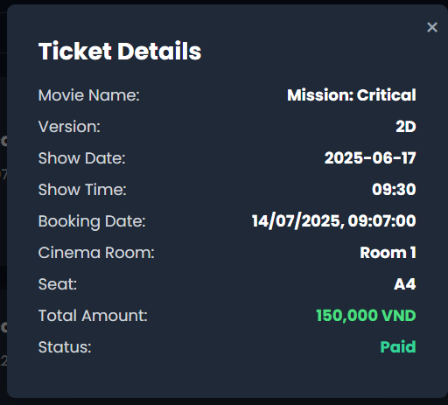

| **Screen** | Ticket Details | | |
| --- | --- | --- | --- |
| **Description** | This screen is shown as a modal popup when the user clicks **View Ticket** from the Booking History page. It displays full ticket information. | | |
| **Screen**  **Access** | This screen is accessed from the Booking History page, specifically by clicking the “View Ticket” button of a booking item. | | |
| **Screen Content** | | | |
| **Item** | **Data** | **Description** | |
| Movie name | ticket.movieName | Title of the booked movie | |
| Version | ticket.version | Version of the movie displayed | |
| Show Date | ticket.scheduleShow | The date of the movie screening | |
| Show Time | ticket.scheduleShowTime | The time of the movie screening | |
| Booking Date | ticket.bookingDate | Timestamp when the ticket was booked | |
| Cinema Room | ticket.cinemaRoomName | The cinema room assigned to the ticket | |
| Seat | ticket.seat | The booked seat(s). | |
| Total Amount | ticket.totalMoney | Final price paid for the ticket | |
| Status | ticket.status *"Paid"* (true), *"Unpaid"* (false) | Payment status of the ticket | |
| **Screen Action** | | | |
| **Action name** | **Description** | **Success** | **Failure** |
| On Modal Open | Triggered when clicking “View Ticket” button. Calls API to fetch ticket detail. | Ticket details are displayed inside the modal. Status shows "Paid" or "Unpaid". | Displays message: "Ticket not found." or loading error |
| On Modal Close | Triggered when clicking the (×) close button on the modal. Hides modal and resets ticket state. | Modal is successfully closed and cleared | No visible effect if state doesn't reset properly |

### Ticket selling management

|  |  |
| --- | --- |
| Use Case  Name | Ticket selling management |
| Use Case ID |  |
| High Level  Requirement Ref |  |
| Actor | Admin/Manager/Admin |
| Description | Allows the user to manage selling ticket |
| Trigger | N/A |
| Pre-condition | The user must log in the system |
| Post-  processing |  |

* + - 1. **Ticket selling management – Select movie and showtime**

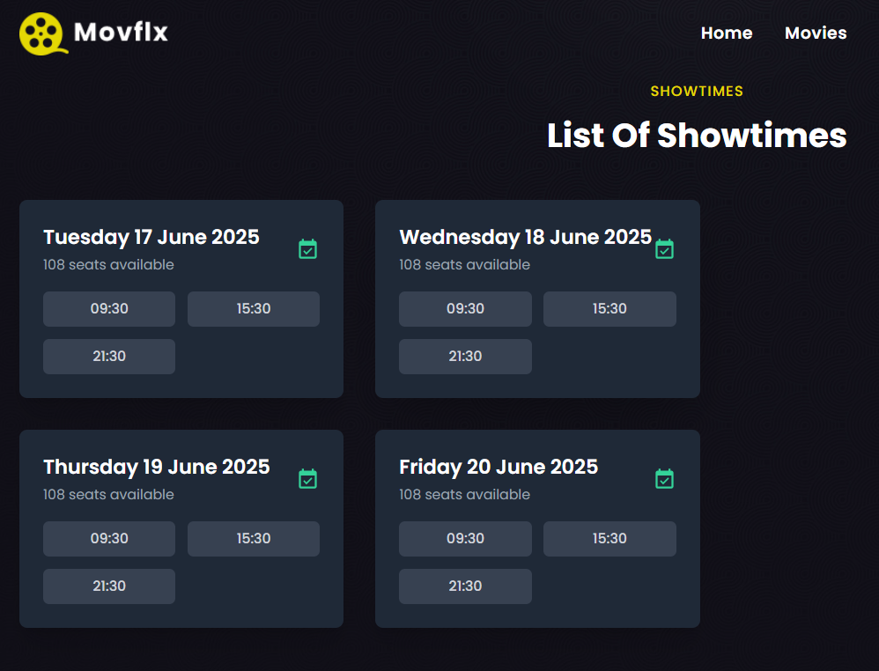

|  |  |  |  |  |
| --- | --- | --- | --- | --- |
| **Screen** | Booking ticket – Select movie and showtime | | | |
| **Description** | Display current movies and showtime | | | |
| **Screen**  **Access** | The user accesses Booking ticket | | | |
| **Screen Content** | | | | |
| **Item** | **Type** | **Data** | **Description** | |
| Date | Combobox | N/A |  | |
| Showtime | Button | N/A |  | |
| Movie name | Label | N/A |  | |
| Time | Link | N/A |  | |
| **Screen Action** | | | | |
| **Action name** | **Description** | | **Success** | **Failure** |
| View showtime | Display list of show dates for the user to select | | Display showtime list of current movies | If no showtime has been found, display message: “No  showtime” |
| Showtime | Display showtime of each movie | | Send information of movies and showtimes, display the Select seat  screen |  |

* + - 1. **Ticket selling management – Selecting seat**

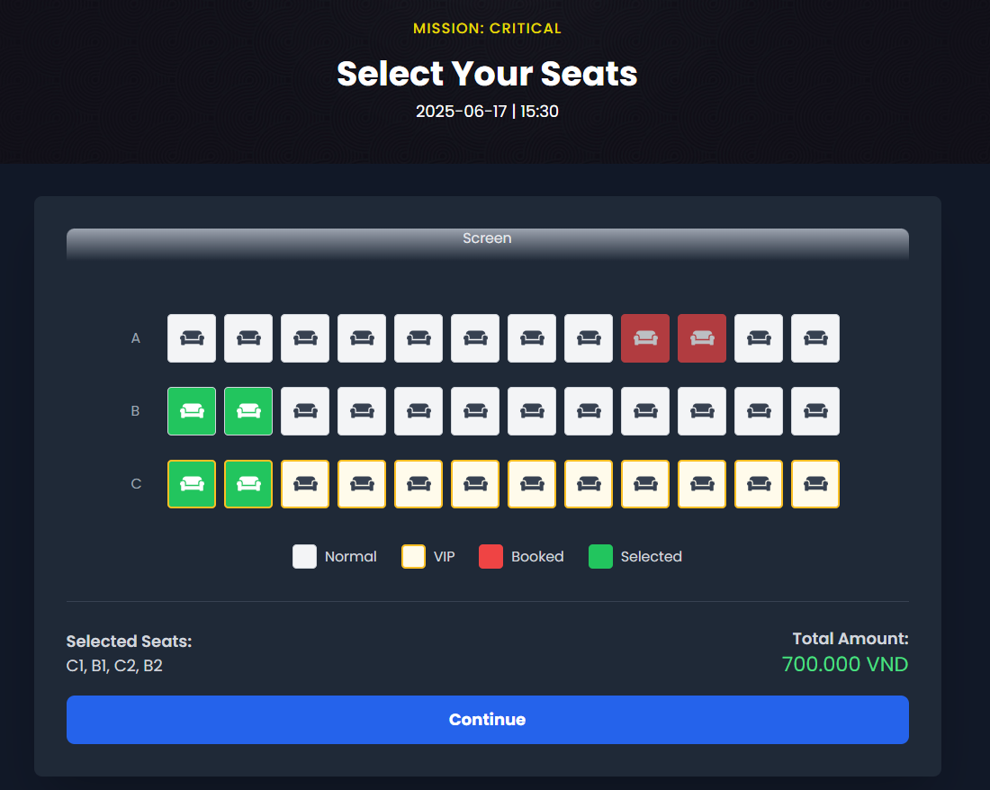

|  |  |  |  |  |
| --- | --- | --- | --- | --- |
| **Screen** | Booking ticket – Select seat | | | |
| **Description** | Display seat map of the movie and selected showtime | | | |
| **Screen**  **Access** | The user accesses after selecting movie and showtime | | | |
| **Screen Content** | | | | |
| **Item** | **Type** | **Data** | **Description** | |
| Select seat  quanity | Combobox | N/A | Display list of seat quantity for the  user to select | |
| Seat | CheckBox | N/A | Display seat map for the user to select | |
| Continue | Button | N/A | Send information of selecting seat and  display ticket booking information | |
| **Screen Action** | | | | |
| **Action name** | **Description** | | **Success** | **Failure** |

|  |  |  |  |
| --- | --- | --- | --- |
| Select seat  quantity | Display list of seat quantity that  customer needs (0, 1, 2, …8) | Display list of seat  quantity |  |
| Select seat | Display seat map, the employee chooses seat according to selected seat quantity at Combobox of Select seat quantity. | When selecting the seat number as the same as selected seat quantity in combobox of Select seat quantity | If selected seat number is less than the seat quantity at the combobox, display the message "Please selecte x seat more"  - If selected seat number is more than the seat quantity at the combobox, display the message "Please select only x  seat" |
| Continue | Send ticket booking request, send seat  selection information and display booking information screen | Display Confirm  booking ticket screen |  |

* + - 1. **Ticket selling management – Confirm ticket**

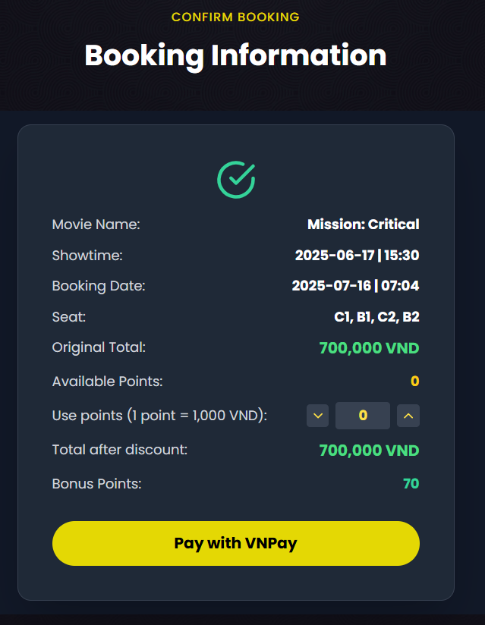

|  |  |  |  |
| --- | --- | --- | --- |
| **Screen** | Ticket selling management – Confirm ticket | | |
| **Description** | Display booking information after selecting seats, allowing users to confirm payment. | | |
| **Screen**  **Access** | The user accesses this screen after selecting seats in the booking process. | | |
| **Screen Content** | | | |
| **Item** | **Type** | **Data** | **Description** |
| Movie name | Label | N/A | Display selected movie title |
| Showtime | Label | N/A | Date and time of the movie |
| |  | | --- | | Booking date |  |  | | --- | |  | | Label | N/A | The date/time the booking is being made |
| Seat | Label | N/A | List of selected seats |
| Original total | Label | N/A | Total amount before discounts |
| Available points | Label | N/A | Number of loyalty points available for the member |
| Use points | Numeric stepper | N/A | Field to select number of points to use |
| Total after discount | Textbox | N/A | Total amount after applying points/discounts |
| Bonus points | Button | N/A | Points awarded after booking |
| Pay with VNPay | Button | N/A | Initiates payment via VNPay |

|  |  |  |  |
| --- | --- | --- | --- |
| **Screen Action** | | | |
| **Action name** | **Description** | **Success** | **Failure** |
| Use points | Adjusts total after discount based on points used | |  | | --- | | Total updated accordingly |  |  | | --- | |  | | Error if exceeding available points |
| Pay with VNPay | Initiates VNPay payment and confirms booking | |  | | --- | | Redirects to VNPay and returns booking confirmation |  |  | | --- | |  | | Shows error message if payment fails |

* + - 1. **Ticket selling management – Confirm ticket**

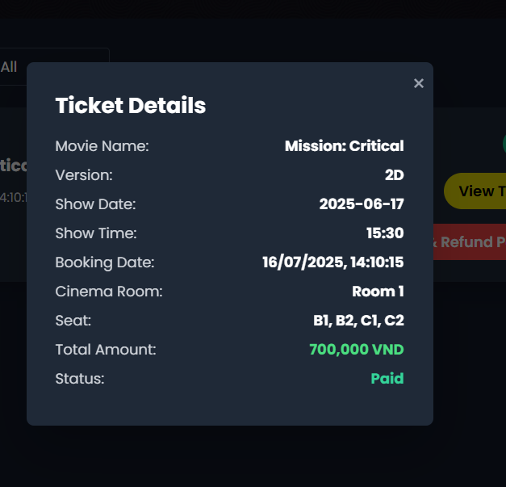

|  |  |  |  |
| --- | --- | --- | --- |
| **Screen** | Ticket selling management – Confirm ticket | | |
| **Description** | Display ticket details after successful booking confirmation. | | |
| **Screen**  **Access** | The user accesses this screen immediately after confirming and completing payment for the ticket. | | |
| **Screen Content** | | | |
| **Item** | **Type** | **Data** | **Description** |
| Movie name | Label | N/A | |  | | --- | | Display booked movie title |  |  | | --- | |  | |
| Version | Label | N/A | |  | | --- | | Display movie version (e.g., 2D, 3D) |  |  | | --- | |  | |
| Show date | Label | N/A | |  | | --- | | Display date of the movie showtime |  |  | | --- | |  | |
| Show time | Label | N/A | |  | | --- | | Display time of the movie showtime |  |  | | --- | |  | |
| Booking date | Label | N/A | |  | | --- | | Display the date and time the booking was made |  |  | | --- | |  | |
| Cinema room | Label | N/A | |  | | --- | | Display cinema room/screen name |  |  | | --- | |  | |
| Seat | Label | N/A | |  | | --- | | Display booked seat numbers |  |  | | --- | |  | |
| Total amount | Label | N/A | |  | | --- | | Display total price of the booking |  |  | | --- | |  | |
| Status | Label | N/A | Display booking payment status (e.g., Paid) |

|  |  |  |  |
| --- | --- | --- | --- |
| **Screen Action** | | | |
| **Action name** | **Description** | **Success** | **Failure** |
| View ticket | |  | | --- | | Display ticket details for the booking |  |  | | --- | |  | | |  |  |  | | --- | --- | --- | | |  | | --- | | Ticket details displayed successfully |  |  | | --- | |  | |  |  | | --- | |  | | Show error if details cannot be retrieved |

### Ticket booking management

|  |  |
| --- | --- |
| Use Case  Name | Ticket booking management |
| Use Case ID |  |
| High Level Requirement  Ref |  |
| Actor | Admin/Manager/Employee |
| Description | Allows the users to manage ticket booking of members or guests, including seat selection, member verification, point redemption, and payment confirmation. |
| Trigger | |  | | --- | | User selects seats for a showtime and proceeds to booking confirmation. |  |  | | --- | |  | |
| Pre-condition | The user must log in to the system. - Showtime and seat information must be available. |
| Post-  processing | - Booking record is stored in the database. - Selected seats are marked as booked. - Member points are updated if redeemed or awarded. - Payment transaction is recorded. |

* + - 1. **Ticket booking management – Search**

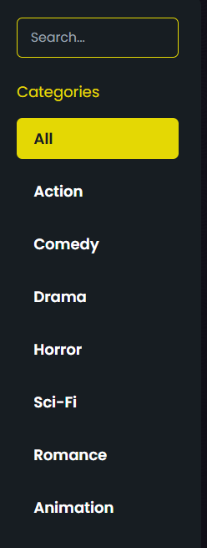

|  |  |
| --- | --- |
| **Screen** | Ticket booking management - Search |
| **Description** | Display current movies and showtime |
| **Screen**  **Access** | The user accesses Ticket booking management |

|  |  |  |  |  |
| --- | --- | --- | --- | --- |
| **Screen Content** | | | | |
| **Item** | **Type** | **Data** | **Description** | |
| Search | Textbox | N/A | Input the keywords to search including Booking ID, account ID, phone number or identity card number of  booking account | |
| Search | Button | N/A | Select Search button | |
| **Screen Action** | | | | |
| **Action name** | **Description** | | **Success** | **Failure** |
| Search | Click the search button, the booking list will filter the data  Filtering data by keyword entered in the search textbox matches with the booking code, account code, phone number or identity card number of the booking account, then display on the  list | | Display the booking list of the account | Show the message "No booking found!" |

* + - 1. **Ticket booking management – Booking list**

|  |  |
| --- | --- |
| **Screen** | Ticket booking management – Booking list |
| **Description** | Display current movies and showtime |
| **Screen**  **Access** | The user accesses Booking ticket |

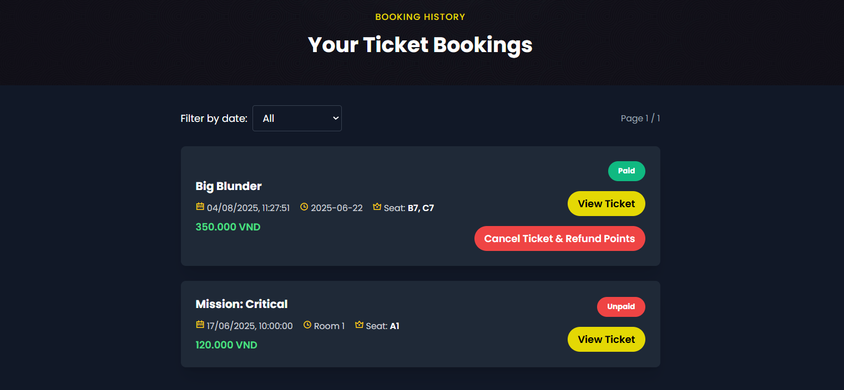

|  |  |  |  |  |
| --- | --- | --- | --- | --- |
| **Screen Content** | | | | |
| **Item** | **Type** | **Data** | **Description** | |
| Booking ID | Label | N/A |  | |
| Identity card | Label | N/A |  | |
| Phone  number | Label | N/A |  | |
| Movie | Label | N/A |  | |
| Time | Label | N/A |  | |
| Successful  booking | Button | N/A |  | |
| **Screen Action** | | | | |
| **Action name** | **Description** | | **Success** | **Failure** |
| Confirm booking | Click Confirm booking to view booking information | | Display information of booking detail of  member |  |

* + - 1. **Ticket booking management – Information of converting into ticket**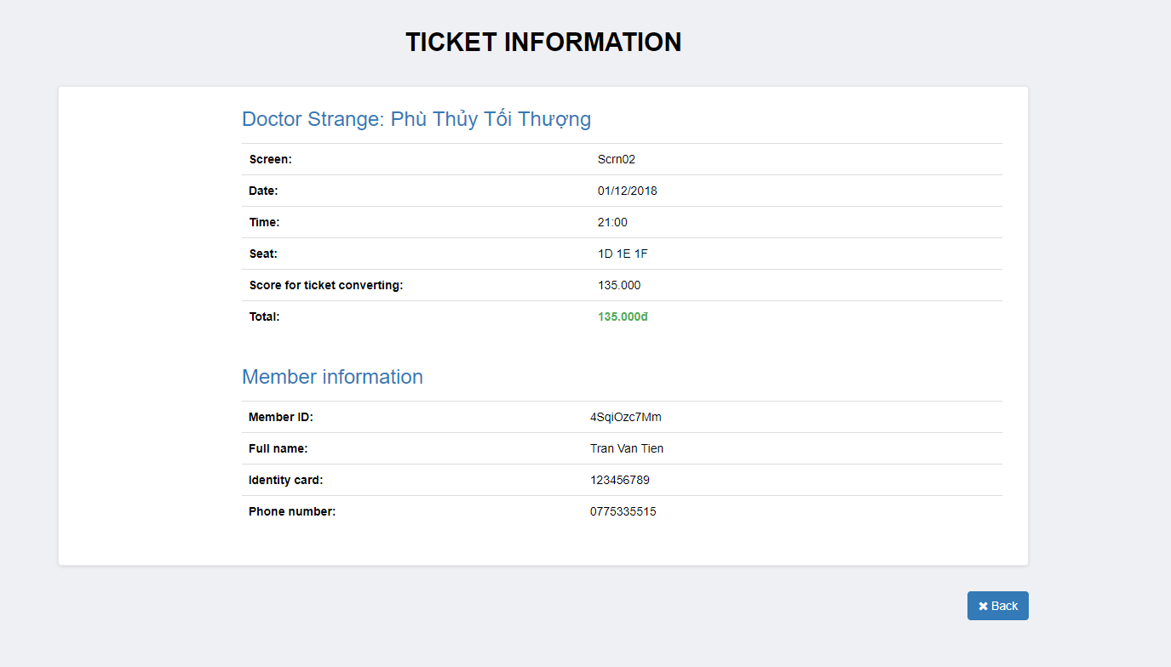

|  |  |  |  |
| --- | --- | --- | --- |
| **Screen** | Booking management – Confirm booking successfully | | |
| **Description** | Display all booking information | | |
| **Screen**  **Access** | The user accesses after selecting Booking ticket at booking list | | |
| **Screen Content** | | | |
| **Item** | **Type** | **Data** | **Description** |
| Movie name | Label | N/A |  |
| Booking ID | Label | N/A |  |
| Screen | Label | N/A |  |
| Date | Label | N/A |  |
| Time | Label | N/A |  |
| Seat | Label | N/A |  |
| Price | Label | N/A |  |
| Convert to  ticket | Label | N/A |  |
| Score for ticket  converting | Label | N/A |  |

|  |  |  |  |  |
| --- | --- | --- | --- | --- |
| Total | Label | N/A |  | |
| Member ID | Label | N/A |  | |
| Full name | Label | N/A |  | |
| Identity card | Label | N/A |  | |
| Phone  number | Label | N/A |  | |
| **Action name** | **Description** | | **Success** | **Failure** |

### Employee management

|  |  |
| --- | --- |
| Use Case Name | Employee management |
| Use Case ID |  |
| High Level  Requirement Ref | Admin/Manager |
| Actor | Admin. |
| Description | This use case allows administrators to manage movie theater employees including adding, editing, deleting, and searching for employees. It also supports employee password management. |
| Trigger | Admin initiates management actions via UI |
| Pre-condition | Admin must login the system |
| Post-processing | Employee data is updated in the system; user receives confirmation notifications (toast) |

* + - 1. **Employee management – View employee list**

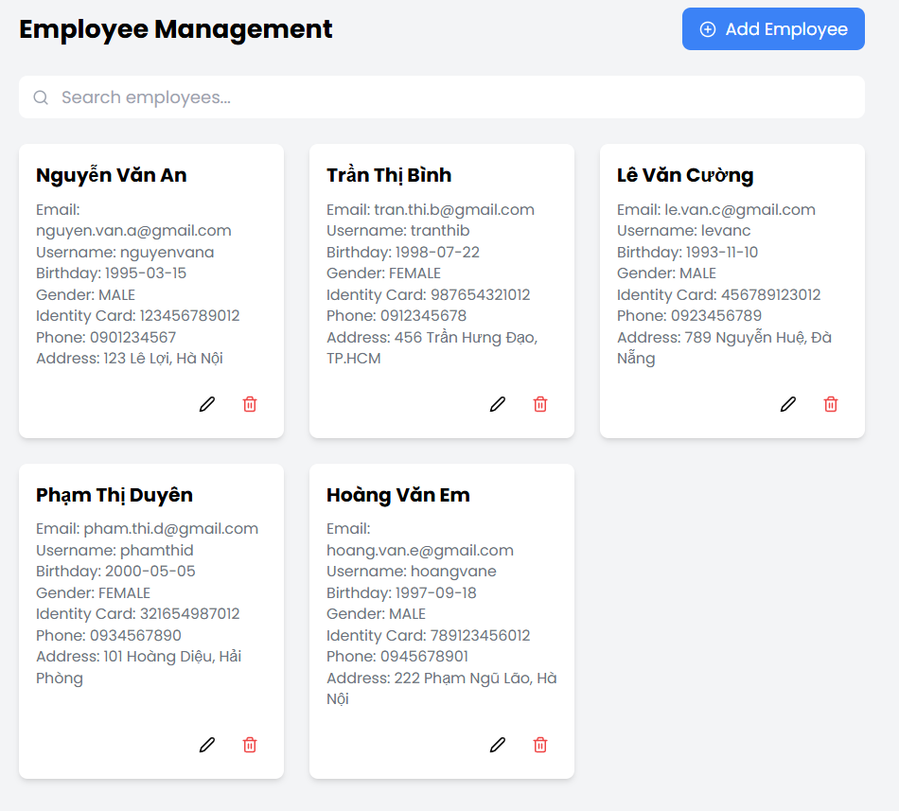

|  |  |  |  |
| --- | --- | --- | --- |
| **Screen** | Screen to display employee list | | |
| **Description** | Displays a list of employees with options to search, add, edit, or delete. | | |
| **Screen**  **Access** |  | | |
| **Screen Content** | | | |
| **Item** | **Type** | **Data** | **Description** |

|  |  |  |  |  |  |
| --- | --- | --- | --- | --- | --- |
| Employee ID | Label | Internal | Unique identifier for the employee | | |
| Employee  name | Label | String | Full name of the employee | | |
| Username | Label | String | Login username | | |
| Identity card | Label | String | Citizen/identity card number | | |
| Email | Label | String | Employee's email address | | |
| Phone  number | Label | String | Contact phone number | | |
| Address | Label | String | Residential address | | |
| Birthday | Label | String (Date) | Display in YYYY-MM-DD format | | |
| Gender | Label | String | Male/ Female/ Other | | |
|  |  |  |  | | |
|  |  |  |  | | |
|  |  |  |  | | |
| Edit | Button | N/A | Triggers modal to edit employee info | | |
| Delete | Button | N/A | Triggers confirmation modal to delete | | |
| Add | Button | N/A | Opens modal to add new employee | | |
| Search | TextBox -  nvarchar (28) | N/A | Input for search keyword | | |
| Search button | Button | N/A | Executes the search | | |
| **Screen Action** | | | | | |
| **Action name** | **Description** | | **Success** |  | **Failure** |
| Add | Click Add to open modal | | Employee added and list updates |  | Toast error |
| Edit | Click Edit icon | | Employee updated |  | API error or validation failed |
| Delete | Click Delete icon | | Employee removed from list |  | API error |
| Search | Type and press search | | Filtered list appears |  | "No results" shown |

* + - 1. **Employee management – Add employee**

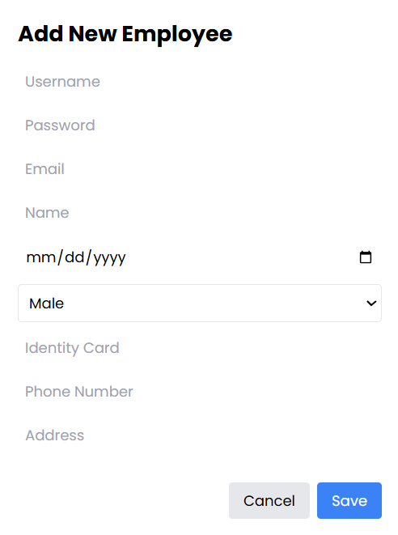

|  |  |  |  |
| --- | --- | --- | --- |
| **Screen** | Screen to add employee | | |
| **Description** | Modal to input and submit information to create a new employee | | |
| **Screen**  **Access** |  | | |
| **Screen Content** | | | |
| **Item** | **Type** | **Data** | **Description** |
| Username | TextBox -  String | N/A | Placeholder for employee image (optional) |
| Password | TextBox -  String | N/A | Required only when adding a new employee |
| Email | TextBox -  String | N/A | Employee email address |
| Name | TextBox -  String |  | Full name of the employee |
| Birthday | TextBox -  String |  | Date of birth (YYYY-MM-DD) |
| Gender | Dropdown-  String | MALE/FEMALE/OTHER | Gender selection |
| Identity Card | TextBox -  String |  | National ID number |
| Phone Number | TextBox -  String |  | Phone number |
| Address | TextBox -  String |  | |  | | --- | |  |  |  | | --- | | Full address of the employee | |
| Cancel | Button |  | Closes the modal without saving |
| Save | Button |  | Submits the form to add or update the employee |

|  |  |  |  |
| --- | --- | --- | --- |
| **Screen Action** | | | |
| **Action name** | **Description** | **Success** | **Failure** |
| Save | Click "Save" after filling required fields | Add inputted employee information into database.  Forward to Employee management screen – View employee  list | Client-side validation fails |
| Cancel | Click "Cancel" to close without saving | Back to previous  screen | N/A |

* + - 1. **Employee management – Edit employee**

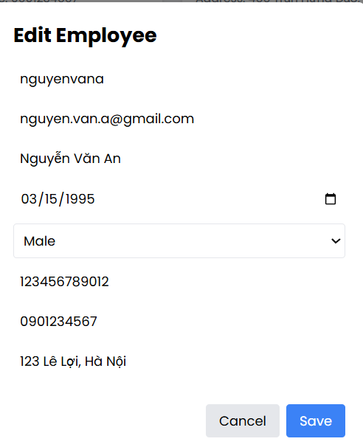

|  |  |  |  |
| --- | --- | --- | --- |
| **Screen** | Screen to edit employee | | |
| **Description** | Function to edit employee information | | |
| **Screen**  **Access** |  | | |
| **Screen Content** | | | |
| **Item** | **Type** | **Data** | **Description** |
| Username | TextBox - String | Current employee’s data |  |
| Email | TextBox - String | Current employee’s data |  |
| Full Name | TextBox - String | Current employee’s data |  |
| Birthday | TextBox - String (Date) | Current employee’s data | yyyy-mm-dd format |

|  |  |  |  |  |
| --- | --- | --- | --- | --- |
| Gender | Dropdown | Current employee’s data | Options: MALE / FEMALE / OTHER | |
| Identity Card | TextBox | Current employee’s data |  | |
| Phone Number | TextBox - String | Current employee’s data |  | |
| Address | TextBox - String | Current employee’s data |  | |
| Cancel | Button |  | Closes modal without saving | |
| Save | Button |  | Submits form and updates employee info | |
| **Screen Action** | | | | |
| **Action name** | **Description** | | **Success** | **Failure** |
| Save | Edit information of an employee | | Edit successfully information of an employee. Edit information of employee in database. Forward to screen of employee management –  View employee list | Shows toast error or logs issue in console |
| Cancel | Back to the previous screen | | Back to the  previous screen | N/A |

* + - 1. **Employee management – Delete employee**

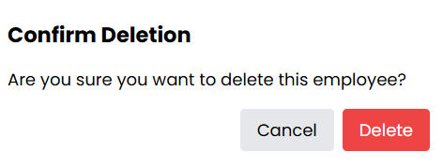

|  |  |  |  |
| --- | --- | --- | --- |
| **Screen** | Screen to delete employee | | |
| **Description** | Function to delete employee information | | |
| **Screen**  **Access** |  | | |
| **Screen Content** | | | |
| **Item** | **Type** | **Data** | **Description** |

|  |  |  |  |  |
| --- | --- | --- | --- | --- |
| Confirmation | Message Box | N/A | Display confirmation prompt: *"Are you sure you want to delete this employee?"* | |
| Delete | TextBox - nvarchar (28) | N/A | Confirm deletion of the employee | |
| Cancel | Button | N/A | Cancel and close the modal | |
| **Screen Action** | | | | |
| **Action name** | **Description** | | **Success** | **Failure** |
| Delete | Delete an employee | | Employee is removed from list (deleted via API), success toast shown | Shows error in console (logged) |

|  |  |  |  |
| --- | --- | --- | --- |
| Back | Cancel deletion and close the modal | Modal closes without deleting | N/A |

### 3.1.7…. User management

|  |  |
| --- | --- |
| Use Case Name | Employee management |
| Use Case ID |  |
| High Level  Requirement Ref | Admin |
| Actor | Admin. |
| Description | Admin can view, search, ban, and unban system users. Supports displaying ban messages and role/status updates.. |
| Trigger | Admin accesses the user management interface. |
| Pre-condition | Admin must login the system |
| Post-processing | User data is updated, including ban status and messages. Toast notifications confirm actions. |

3.1.7.2 Viewing Users  
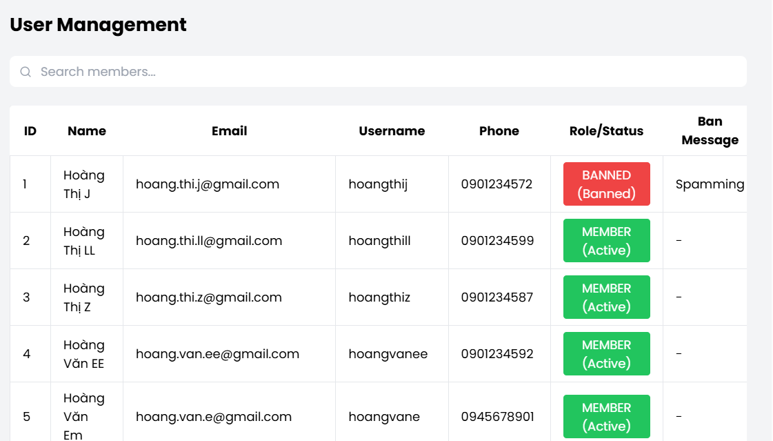

|  |  |  |  |
| --- | --- | --- | --- |
| **Screen** | User Management | | |
| **Description** | Function to see users information | | |
| **Screen**  **Access** | Admin clicks **"User Management"** in the navigation menu. | | |
| **Screen Content** | | | |
| **Item** | **Type** | **Data** | **Description** |
| Search | Textbox - String |  | Filters users by name, username, email, or phone number |
| Table | TextBox - String |  | Displays user information in rows |
| Ban Message | TextBox - String (Date) |  | Message shown if user is banned |

|  |  |  |  |  |
| --- | --- | --- | --- | --- |
| Role/Status | Button - String |  | Role (e.g., USER, ADMIN) + status (Active/Banned). Clickable button to toggle. | |
| ID | TextBox - Number |  | Row index (not database ID) | |
| Name | TextBox - String |  | User’s full name | |
| Email | TextBox - String |  | User’s email | |
| Username | TextBox - String |  | System login username | |
| Phone | TextBox - String |  | Registered phone number | |
| **Screen Action** | | | | |
| **Action name** | **Description** | | **Success** | **Failure** |
| Search | . | | Filters the user list based on the entered search term | N/A ( |
| Ban User | Back to the previous screen | | Opens modal → Admin enters message → User gets banned → Data is reloaded and toast shown | Error toast shown; fallback data fetch triggered on failure. |
| Unban User |  | | User is immediately unbanned without modal → Data is reloaded and toast shown. | Error toast shown; fallback data fetch triggered on failure. |
| Refresh |  | | Data is re-fetched after each ban/unban operation. | Error toast shown; logs issue in console if fetch fails. |

3.1.7…. Enter Ban Message

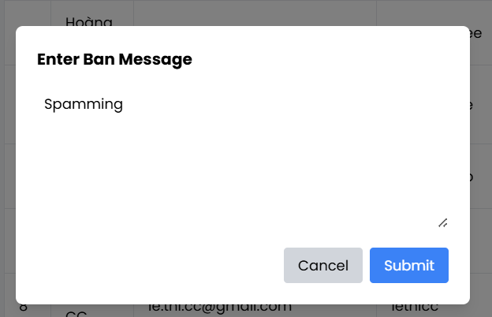

|  |  |  |  |
| --- | --- | --- | --- |
| **Screen** | Ban Message Modal | | |
| **Description** | Function to ban user | | |
| **Screen**  **Access** | Admin only | | |
| **Screen Content** | | | |
| **Item** | **Type** | **Data** | **Description** |

|  |  |  |  |  |
| --- | --- | --- | --- | --- |
| Ban Message | Text | N/A | Admin inputs reason for banning. Required. Max length (enforced in parent). | |
| Error Message | Text (conditional) | N/A | Displays an error if message is empty or too long. | |
| Cancel | Button | N/A | Closes the modal without submitting. | |
| Submit | Button |  | Triggers the onSubmit function to proceed with the ban and close the modal. | |
| **Screen Action** | | | | |
| **Action name** | **Description** | | **Success** | **Failure** |
| Submit |  | | Validates message. If valid, ban user | show error |
| Cancel |  | | Close without saving | N/A |

3.1.7…… User see ban message

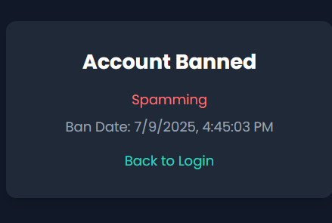

|  |  |  |  |
| --- | --- | --- | --- |
| **Screen** | Ban Message Modal | | |
| **Description** | Function to ban user | | |
| **Screen**  **Access** | Any one | | |
| **Screen Content** | | | |
| **Item** | **Type** | **Data** | **Description** |

|  |  |  |  |  |
| --- | --- | --- | --- | --- |
| Ban Message | Text | N/A | Reason for the ban | |
| Ban Date | Date (ISO Timestamp) | N/A | Formatted time when the ban was activated | |
| Back to Login | Link Button | N/A | Navigates user back to the login screen. | |
| **Screen Action** | | | | |
| **Action name** | **Description** | | **Success** | **Failure** |
| Show Ban Message | Login attempt by a banned user | | Redirected to ban screen with reason and timestamp | N/A |
| Back to Login | Click "Back to Login" link | | User is navigated back to the login form | N/A |

### Cinema room management

|  |  |
| --- | --- |
| Use Case Name | Cinema room management |
| Use Case ID |  |
| High Level Requirement  Ref | Manage cinema rooms (add, edit, delete, search, and view seat details) |
| Actor | Admin (full access) |
| Description | Allows admin to manage cinema rooms: add, edit, delete, search, and view. |
| Trigger | Admin accesses the Cinema Room Management screen after login. |
| Pre-condition | - Admin must be logged in.  - Only admin can perform these functions. |

* + - 1. **Cinema room management – Display list of cinema rooms**

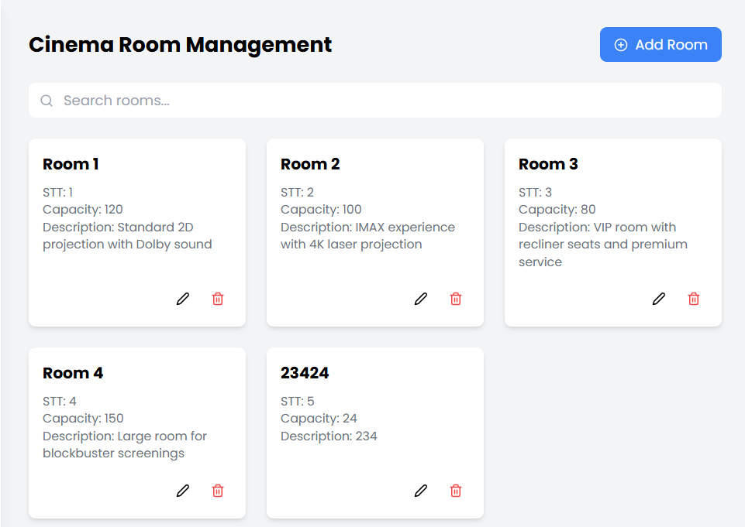

|  |  |  |  |
| --- | --- | --- | --- |
| **Screen** | Cinema Room Dashboard | | |
| **Description** | Displays a list of cinema rooms with search functionality. Allows admin to add, edit, delete rooms, and view seat details. | | |
| **Screen**  **Access** | Admin only (must be authenticated and authorized). | | |
| **Screen Content** | | | |
| **Item** | **Type** | **Data** | **Description** |
| Cinema room  ID | Label | Auto-generated | Unique identifier for each cinema room. |

|  |  |  |  |  |
| --- | --- | --- | --- | --- |
| Cinema room | Label | Text | Name of the cinema room. | |
| Seat quantity | Label | Number | |  | | --- | | Capacity (total number of seats) in the room. |  |  | | --- | |  | | |
| Description | Label | Text | Room description. | |
| Seat detail | Button | Text | Navigates to seat detail screen (currently not implemented in code).   |  | | --- | |  | | |
| Add cinema  room | Button | N/A | Opens modal to add a new cinema room. | |
| Edit Room | Button | N/A | Opens modal to edit selected room’s info. | |
| Delete Room | Button | N/A | Opens confirmation modal to delete selected room. | |
| Search bar | TextBox - | N/A | Input field for searching cinema rooms by name. | |
| Search | Button | N/A | Executes search on keyword entered. | |
| **Screen Actions** | | | | |
| **Action name** | **Description** | | **Success** | **Failure** |
| Add Room | Click “Add Room” button → open modal → fill info → save. | | Room is added and list is refreshed with toast message. | Toast shows failure. |
| |  | | --- | | Edit Room |  |  | | --- | |  | | Click edit icon → open modal → modify info → save. | | Room is updated and list refreshed with toast message. | Toast shows failure. |
| Delete Room | Click delete icon → confirm deletion. | | Room is deleted, removed from list, and toast message shown. | Toast shows error text from backend. |
| Search | Enter keyword → click search or type triggers filter. | | List updates with matching rooms instantly. | No matching rooms shown. |
| Seat detail | (Planned feature) Click Seat Detail button to view/edit seat type. | | Navigate to seat detail screen (not implemented in current code). | N/A |
| Cancel | Click "Cancel" inside modal to close without saving. | | Modal closes, no changes made. | N/A |
| Back | Use browser or app navigation to return to previous screen | | User is returned to previous screen. | N/A |

3.1.8.2 Editing cinemaroom detail

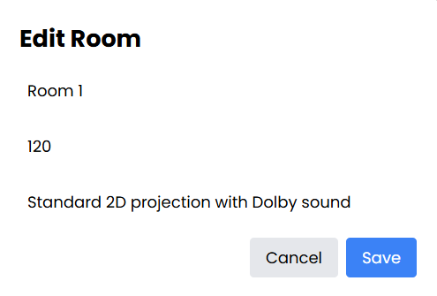

|  |  |  |  |
| --- | --- | --- | --- |
| **Screen** | Cinema Room Dashboard | | |
| **Description** | Edit Cinema Room | | |
| **Screen**  **Access** | Admin only (must be authenticated and authorized). | | |
| **Screen Content** | | | |
| **Item** | **Type** | **Data** | **Description** |
| Edit Room | Button / Icon | N/A | Opens modal with the selected room's current details for editing.. |

|  |  |  |  |  |
| --- | --- | --- | --- | --- |
| Room Name | TextBox | roomName | Editable input field for the cinema room name. | |
| Capacity | Number | capacity | Editable input field for seat capacity (number of seats).   |  | | --- | |  | | |
| Description | TextBox | description | Editable input field for the room's description. | |
| Save | Button | N/A | Submits the updated data to the backend.   |  | | --- | |  | | |
| Cancel | Button | N/A | Closes the modal without saving any changes | |
| Toast Message | Feedback | Success / Failure | Displays toast message after submission (success or error from backend).. | |
| **Screen Actions** | | | | |
| **Action name** | **Description** | | **Success** | **Failure** |
| Edit Room | Click edit icon → open modal → update fields → click save. | | Room is updated, modal closes, room list refreshes, success toast appears. | Modal stays open, error toast appears. |
| Cancel Edit   |  | | --- | |  | | Click "Cancel" inside modal. | | Modal closes without saving. | N/A |
| Form Validation | Ensure all fields are filled correctly (e.g., capacity must be a number ≥ 1). | | Prevents bad data from being submitted. | Inline or toast error shown. |

3.1.8.3 Add new cinema room

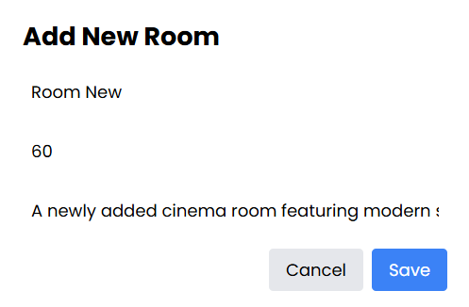

|  |  |  |  |
| --- | --- | --- | --- |
| **Screen** | Cinema Room Dashboard | | |
| **Description** | Add Cinema Room | | |
| **Screen**  **Access** | Admin only (must be authenticated and authorized). | | |
| **Screen Content** | | | |
| **Item** | **Type** | **Data** | **Description** |
| Add Room | Button / Icon | N/A | Opens modal with empty fields to input new room information. |

|  |  |  |  |  |
| --- | --- | --- | --- | --- |
| Room Name | TextBox | roomName | Input field for the new cinema room name. | |
| Capacity | Number | capacity | Input field for seat capacity (number of seats).   |  | | --- | |  | | |
| Description | TextBox | description | Input field for the room's description. | |
| Save | Button | N/A | Submits the new data to the backend to create the room. | |
| Cancel | Button | N/A | Closes the modal without saving any data. | |
| Toast Message | Feedback | Success / Failure | Displays toast message after submission (success or error from backend). | |
| **Screen Actions** | | | | |
| **Action name** | **Description** | | **Success** | **Failure** |
| Add Room | Click “Add Room” button → open modal → fill fields → click Save. | | Room is added, modal closes, room list refreshes, success toast appears. | Modal stays open, error toast appears. |
| Cancel Add   |  | | --- | |  | | Click "Cancel" inside modal. | | Modal closes without saving. | N/A |
| Form Validation | Ensure all fields are filled correctly (e.g., capacity must be a number ≥ 1). | | Prevents invalid data from being submitted. | Inline or toast error shown. |

3.1.8.4 Delete Cinema room

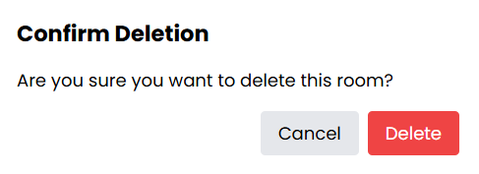

|  |  |  |  |
| --- | --- | --- | --- |
| **Screen** | Cinema Room Dashboard | | |
| **Description** | Delete Cinema Room | | |
| **Screen**  **Access** | Admin only (must be authenticated and authorized). | | |
| **Screen Content** | | | |
| **Item** | **Type** | **Data** | **Description** |
| Delete Room | Button / Icon | N/A | Opens confirmation modal for deleting the selected room. |

|  |  |  |  |  |
| --- | --- | --- | --- | --- |
| Confirmation Modal | Modal | cinemaRoomId | Shows confirmation text: “Are you sure you want to delete this room?” | |
| Confirm Delete | Button | N/A | Submits the delete request to backend | |
| Cancel | Button | N/A | Closes the modal without performing deletion. | |
| Toast Message | Feedback | Success / Failure | Displays toast after deletion attempt. | |
| **Screen Actions** | | | | |
| **Action name** | **Description** | | **Success** | **Failure** |
| Delete Room | Click delete icon → open confirmation modal → click Confirm. | | Room is deleted, modal closes, room is removed from list, success toast appears. | Modal stays open, error toast appears. |
| Cancel Delete   |  | | --- | |  | | Click "Cancel" inside modal. | | Modal closes without deleting the room. | N/A |
| Backend Error Handling | Handles response text from backend if deletion fails | | Error message from backend is displayed via toast. | Room is not deleted. |

* + - 1. **Cinema room management – Cinema room detail**

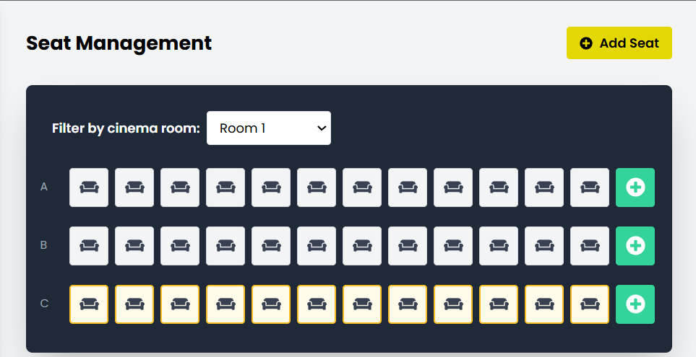

|  |  |  |  |  |
| --- | --- | --- | --- | --- |
| **Screen** | Detail screen of cinema room | | | |
| **Description** | Function to view information and edit seat type in selected cinema room | | | |
| **Screen**  **Access** | From Cinema Room Management screen | | | |
| **Screen Content** | | | | |
| **Item** | **Type** | **Data** | **Description** | |
| Cinema room | Label | Room name | Displays the name of the currently selected cinema room | |
| Seat | Checkbox | Seat ID / Code | Clicking toggles seat type (Normal ↔ VIP) or disables/enables a seat | |
| Save | Button | N/A | Saves seat changes (add/edit) to the database | |
| Back | Button | N/A | Returns to the previous screen | |
| Add Seat | Button | N/A | Opens a modal form to add a new seat manually or by row | |
| Edit Seat | Button | N/A | Opens modal form to edit seat details | |
| Delete Seat | Button | N/A | Opens confirmation modal to delete a seat | |
| Filter by Room | Dropdown | List of rooms | Select a cinema room to manage its seat layout | |
| **Screen Action** | | | | |
| **Action name** | **Description** | | **Success** | **Failure** |
| Select seat | Click on a seat to open its edit modal, or click red × to delete | | Seat highlight updates, edit modal opens | N/a |
| Add seat | Click the green "+" icon to add a seat to a row | | New seat is added visually, saved in DB | Validation or API error |
| Edit seat | Click any seat to edit its row, number, type, or status | | Changes saved and reflected on screen | Edit modal or API fails |
| |  | | --- | | Delete seat |  |  | | --- | |  | | Click "×" icon on seat, confirm delete in modal | | Seat is removed and DB is updated | Toast shows deletion error |
| Save | Submits the add/edit form | | Success toast, seat list is reloaded | Toast shows error message |
| Filter by room | Dropdown selection reloads seat layout of selected room | | Correct seat layout is shown | N/A |
| Back | Return to cinema room list | | Returns to previous screen | N/A |

### Movie management

|  |  |
| --- | --- |
| Use Case  Name | Movie management |
| Use Case ID |  |
| High Level Requirement  Ref |  |
| Actor | Admin/Manager |
| Description | Allows admin to view, add, edit movie information |
| Trigger | The user must log in the system as admin right |
| Pre-condition |  |

* + - 1. 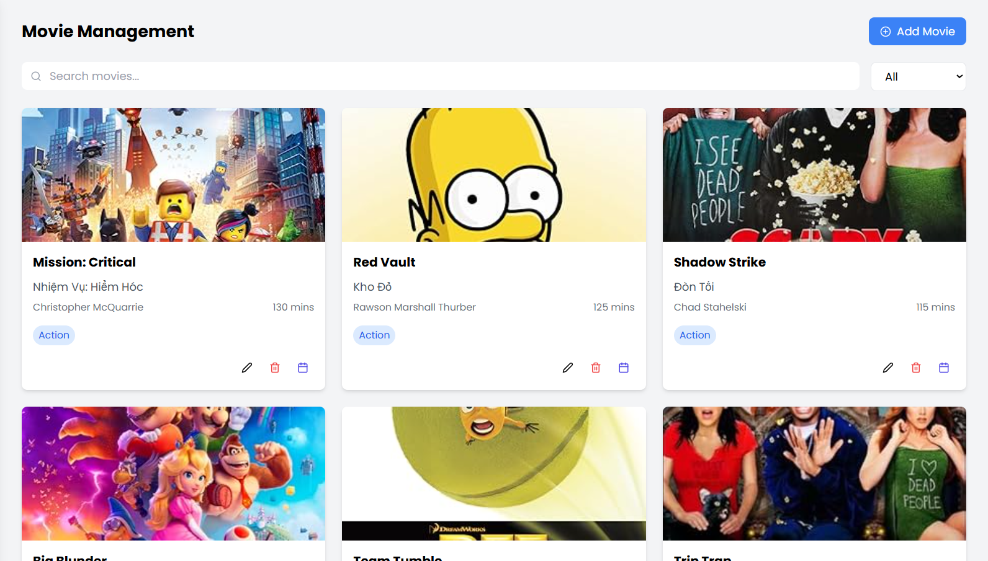**Movie management – View movie list**

|  |  |  |  |
| --- | --- | --- | --- |
| **Screen** | View movie list | | |
| **Description** | Display movie list | | |
| **Screen Access** | The user clicks **Movie management** in the main menu. | | |
| **Screen Content** | | | |
| **Item** | **Type** | **Data** | **Description** |
| Movie | Lable –  String | N/A | |  | | --- | | Display movie title |  |  | | --- | |  | |
| Release date | Lable –  String | N/A | |  | | --- | | Display release date of the movie |  |  | | --- | |  | |

|  |  |  |  |  |  |  |
| --- | --- | --- | --- | --- | --- | --- |
| Movie  production company | | Lable –  String | N/A | | Display the production company name | |
| Movie running  time | | Lable –  Number | N/A | | Display movie duration (minutes) | |
| Version | | Lable –  String | N/A | | Display movie version (e.g., 2D, 3D) | |
| Edit | | Button | N/A | | |  | | --- | | Navigate to edit movie page |  |  | | --- | |  | | |
| Add movie | | Button | N/A | | Navigate to add new movie page | |
| **Screen Action** | | | | | | |
| **Action name** | **Description** | | | **Success** | | **Failure** |
| Add movie | Forward to page of adding movie | | | Display page of  adding movie | |  |
| Edit | Forward to page of editing movie | | | Display page of editing selected movie | |  |

* + - 1. 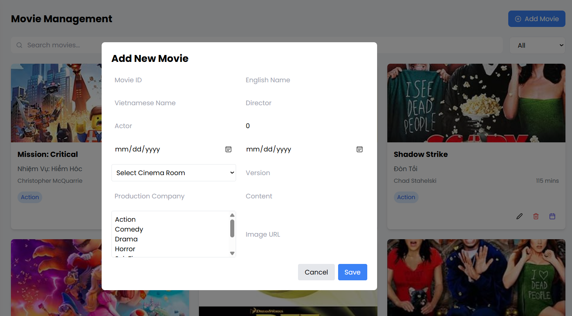**Movie management – Add movie**

|  |  |  |  |
| --- | --- | --- | --- |
| **Screen** | Add movie | | |
| **Description** | Add 1 movie into database | | |
| **Screen Access** | The user clicks **Movie management -> Add movie** | | |
| **Screen Content** | | | |
| **Item** | **Type** | **Data** | **Description** |
| Movie name | TextBox –  String | N/A | |  | | --- | | Input the title of the movie |  |  | | --- | |  | |
| From date | Date | N/A | |  | | --- | | Select the start date for screening |  |  | | --- | |  | |
| To date | Date | N/A | |  | | --- | | Select the end date for screening |  |  | | --- | |  | |

|  |  |  |  |  |  |  |  |  |
| --- | --- | --- | --- | --- | --- | --- | --- | --- |
| Actor | | TextBox –  String | N/A | | |  | | --- | | Input main actors' names |  |  | | --- | |  | | |
| Movie  production company | | TextBox –  String | N/A | | |  | | --- | | Input production company name |  |  | | --- | |  | | |
| Director | | TextBox –  String | N/A | | |  | | --- | | Input director's name |  |  | | --- | |  | | |
| Running time | | TextBox –  Number | N/A | | |  | | --- | | Input movie duration (minutes) |  |  | | --- | |  | | |
| Version | | RadioBox | N/A | | |  | | --- | | Select movie version (e.g., 2D, 3D) |  |  | | --- | |  | | |
| Trailer | | TextBox –  Number | N/A | | |  | | --- | | Input trailer link or ID |  |  | | --- | |  | | |
| Type | | CheckBox | N/A | | |  | | --- | | Select one or more movie genres |  |  | | --- | |  | | |
| Cinema room | | ComboBox | N/A | | |  | | --- | | Select cinema room |  |  | | --- | |  | | |
| Showtime | | TextBox –  String | N/A | | |  | | --- | | Input showtime details |  |  | | --- | |  | | |
| Content | | TextBox –  String | N/A | | |  | | --- | | Input movie synopsis/description |  |  | | --- | |  | | |
| Add cinema  time | | Button | N/A | | |  | | --- | | Add additional cinema time |  |  | | --- | |  | | |
| Choose file | | Button | N/A | | |  | | --- | | Upload poster/image file |  |  | | --- | |  | | |
| Submit | | Button | N/A | | Submit form to add the movie | |
| **Screen Action** | | | | | | |
| **Action name** | **Description** | | | **Success** | | **Failure** |
| Add movie | Add movie into database, after admin inputs all information, then click Add  movie to add movie. | | | Back to page of Movie management | | Display the error message |

* + - 1. 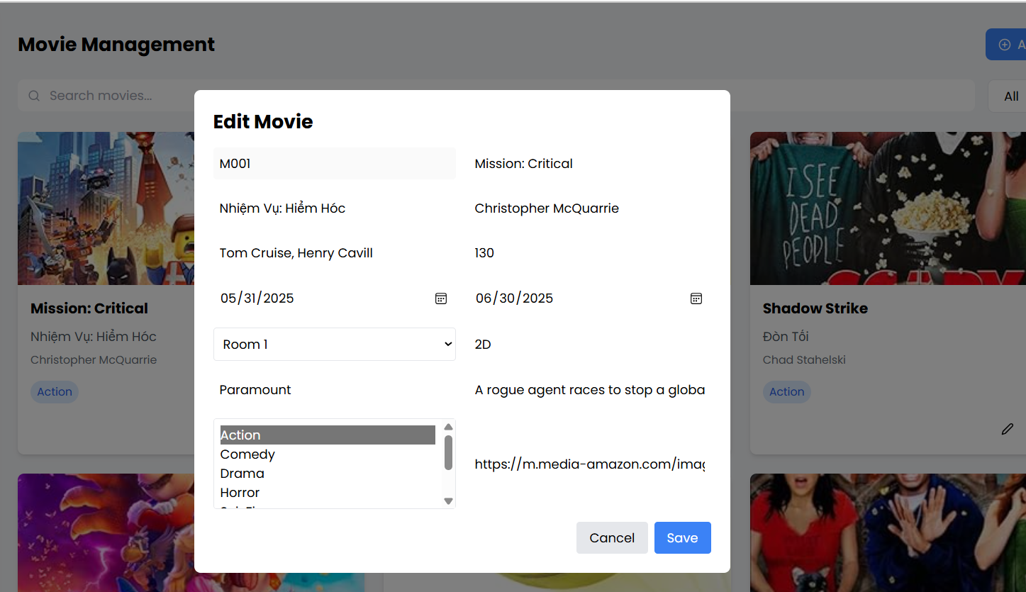**Movie management – Edit movie information**

|  |  |  |  |
| --- | --- | --- | --- |
| **Screen** | Update movie information | | |
| **Description** | Update information of the movie | | |
| **Screen Access** | The user clicks **Movie management -> Edit** | | |
| **Screen Content** | | | |
| **Item** | **Type** | **Data** | **Description** |

|  |  |  |  |  |  |  |  |  |  |  |  |  |
| --- | --- | --- | --- | --- | --- | --- | --- | --- | --- | --- | --- | --- |
| |  | | --- | | Movie ID |  |  | | --- | |  | | | |  | | --- | | Label – String |  |  | | --- | |  | | N/A | | |  | | --- | | Display unique movie identifier (read-only) |  |  | | --- | |  | | |
| English title | | TextBox-String | N/A | | |  | | --- | | Edit movie title in English |  |  | | --- | |  | | |
| |  | | --- | | Vietnamese title |  |  | | --- | |  | | | TextBox-String | N/A | | |  | | --- | | Edit movie title in Vietnamese |  |  | | --- | |  | | |
| Director | | TextBox –  String | N/A | | |  |  |  | | --- | --- | --- | | |  | | --- | | Edit director's name |  |  | | --- | |  | |  |  | | --- | |  | | |
| Actors | | TextBox –  String | N/A | | |  | | --- | | Edit list of actor |  |  | | --- | |  | | |
| Director | | TextBox –  String | N/A | | Edit director’s name | |
| Actors | | TextBox –  String | N/A | | Edit list of actors | |
| Running time | | TextBox –  String | N/A | | Edit movie duration in minutes | |
| From date | | Date | N/A | | Edit start screening date | |
| To date | | Date | N/A | | Edit end screening date | |
| Cinema room | | ComboBox | N/A | | Select/change cinema room | |
| Version | | RadioBox | N/A | | Select/change version (e.g.,2D,3D) | |
| Production company | | TextBox –  String | N/A | | Edit production company | |
| Content | | TextBox –  String | N/A | | Edit sunopsis/description | |
| Type (genre) | | ListBox/CheckBox | N/A | | Select one or more movie genres | |
| Trailer | | TextBox-String | N/A | | Edit trailer link | |
| Cancel | | Button | N/A | | Cancel editing and return to movie list | |
| Save | | Button | N/A | | Save changes to movie information | |
| **Screen Action** | | | | | | |
| **Action name** | **Description** | | | **Success** | | **Failure** |
| Save | Update movie details in the database with the modified information | | | |  | | --- | | Back to movie list with updated details |  |  | | --- | |  | | | Display error messages |
| Cancel | |  | | --- | | Cancel editing and return to movie list |  |  | | --- | |  | | | | |  | | --- | | Return to movie list without changes |  |  | | --- | |  | | |  |

* + - 1. **Movie management – Delete movie**

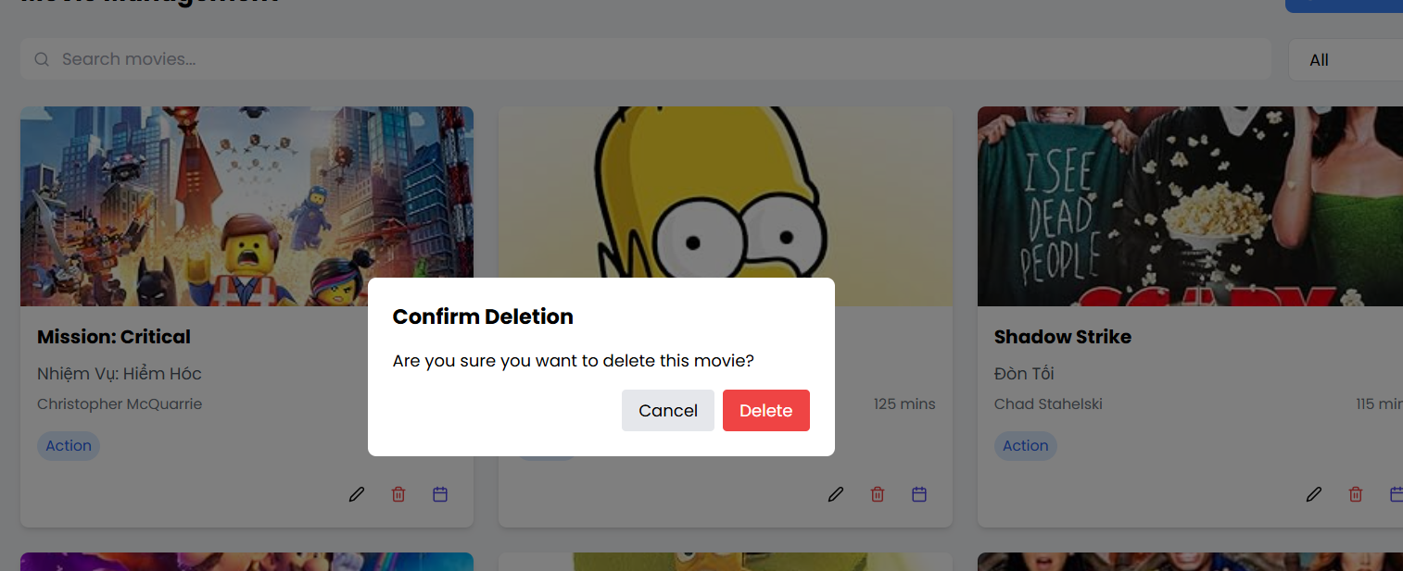

|  |  |  |  |
| --- | --- | --- | --- |
| **Screen** | Movie management – Delete movie | | |
| **Description** | Delete information of the movie | | |
| **Screen Access** | Admin clicks **Movie management → Delete** icon/button on a specific movie from the movie list. | | |
| **Screen Content** | | | |
| **Item** | **Type** | **Data** | |
| Yes | Button |  | |
| No | Button |  | |
| **Screen Actions** | | | |
| **Action Name** | **Description** | | **Success** |
| Confirm | Agree to delete  movies | | The movie is deleted from the database and **Movie list** screen is displayed |
| No | Close confirm screen without deleting movie | | Display Movie list screen |

## Detailed Non-Functional Requirements

### Logical Structure of the Data

The logical structure of the data to be stored on the system is given below

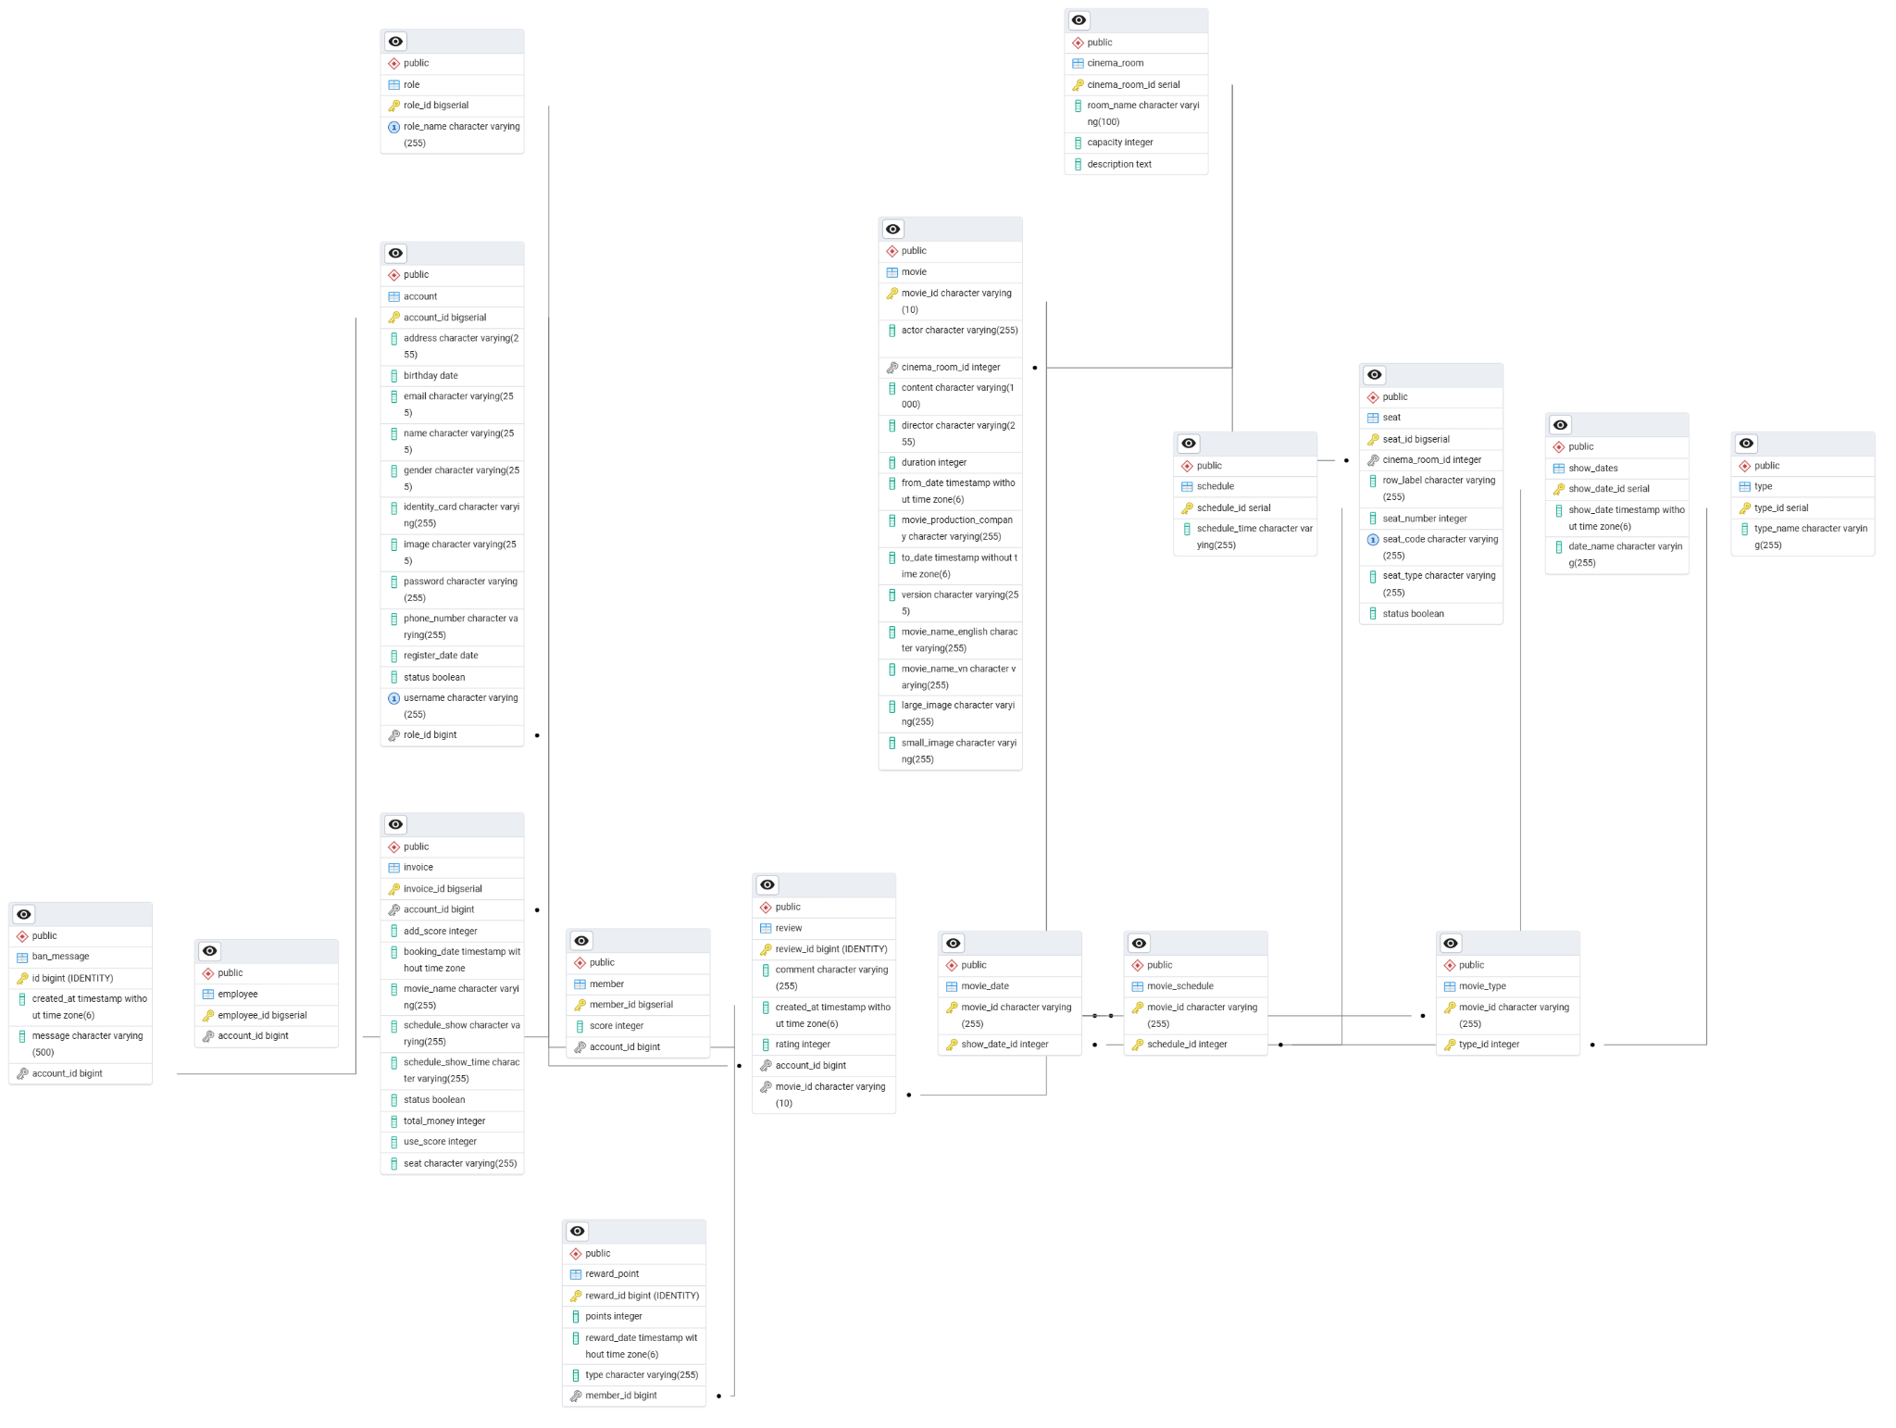

### Security

TBD

### Performance

TBD